Rhino Requirements Specification

Final Version

June 07, 2019

Prepared by:

Aleksandros Ruci

Grent Mustafa

Vasjon Done

Elda Hoxhaj

Marko Doga

Ajni Shehu

Received by:

Dr. Igli Hakrama

Table of Contents

1. Executive Summary 3

1.1 Project Overview 3

1.2 Purpose and Scope of this Specification 3

2. Product/Service Description 3

2.1 Product Context 3

2.2 User Characteristics 3

2.3 Assumptions 3

2.4 Constraints 3

2.5 Dependencies 4

3. Requirements 4

3.1 Functional Requirements 5

3.2 Non-Functional Requirements 5

3.2.1 Product Requirement

3.2.1.1 User Interface Requirements 5

3.2.1.2 Learnability 5

3.2.1.3 Accessibility 6

3.2.1.4 Efficiency 6

3.2.1.5 Memorability 7

3.2.1.6 Errors 8

3.2.1.7 Satisfaction 8

3.2.1.8 Capacity 8

3.2.2 Organizational Requirements 9

3.2.2.1 Availability 9

3.2.2.2 Latency 9

3.2.2.3 Monitoring 9

3.2.2.4 Maintanance 9

3.2.2.5 Operations 9

3.2.2.6 Standart Compliance 10

3.2.2.7 Portability 10

3.2.3 External Requiremens 10

3.2.2.1 Security 10

3.2.2.2 Protection 10

3.2.2.3 Authorization and Authentication 10

3.3 DOMAIN REQUIREMENTS 11

4. software Design / Diagrams 12

4.1 User Scenarios 13

4.2 User scenarios Extended 16

4.3 use cases 26

4.4 Use cases Diagrams 36

4.5 Activity Diagrams 40

4.6 State Diagrams 42

4.7 Collaboration Diagrams 44

4.8 Sequence Diagrams 45

4.9 Class diagram 48

4.10 DB schema diagram 49

4.11 Er Diagram 51

4.12 component diagram 56

4.13 object diagram 58

4.14 Data flow Diagram 60

4.15 deployment diagram 61

5. IMPLEMENTATION TECHNOLOGY 62

6. IMPLEMENTATION TECHNOLOGY 62

4.1 Task distribution chart 63

4.2 network analysis 65

4.3 grantt chart 68

APPENDIX 73

Appendix A. Definitions, Acronyms, and Abbreviations 73

Appendix B. References 73

Appendix C. Requirements Traceability Matrix 74

Appendix D. Organizing the Requirements 75

# Executive Summary

## Project Overview

Businessmen in Albania are concerned that their businesses are not getting the right attention from their customers. They also do not have a platform with which they can reach a high number of customers while providing discounts for them. This is where Rhino, the superhero of discounts comes in help. Rhino is a mobile application which provides instant access to latest discounts. Every business can showcase their discounts and every user can take advantage of those discounts:

* Discounts in categories in which customers are interested
* Latest discounts of every business in your area
* Increase your revenues by increasing your number of customers
* Gather insight of your sales progress

## Purpose and Scope of this Specification

The purpose of this project is to use technology in order to improve customer experience and facilitate business sales. The market of Albania is still suffering and customers have so little information regarding the possibilities they have to save more money. This software will provide a very organized, hybrid and comprehensive solution for these issues. It is going to affect all businesses that want to advertise their products and make discounts online.

# Product/Service Description

This project is going to be served as a full package software. It is going to include a mobile application which will provide every user the interface to find out the newest offers and discounts. It is also going to make possible for every customer to get notified with a push notification regarding the latest offers and the discounts that are only bounded to a number of users. On the other hand, every business will be able to enter latest of its offers and discounts using a web-app we are going to provide. This web-app is going to be used by the administrators of the app as well to register new businesses.

## Product Context

This product is closely related with other businesses that operate in Albania. Apart from that, it is not dependent on any other platform or service thus it relates only to its own implementation. The only dependency that it has, but which counts for most of the startups in the whole world, is that it is going to use Google services. Also, as a start, it is only implemented for Android operating system.

## User Characteristics

There are

* User
  + Users is any person that is interested in finding out what the latest discounts offered by businesses are.
* Business
  + Business is any shop, restaurant etc. that wants to notify everyone regarding their latest discounts
* Admin
  + Admin is the person(s) who registers new businesses that want to be part of our app and show their offers and discounts there.

## Assumptions

It is assumed that most of the clients in Albania have phones with Android operating systems.

It is assumed that businesses have a computer, phone, tablet or any other device connected to the internet that can be used to upload the latest discounts online in real time.

It is assumed that businesses have a person that has a duty and also knows how to use our software.

## Constraints

The system will be potentially constrained by:

* The fact that every business should have a device connected to the internet at the time they want to enter a new discount
* The fact that if a business does not have a device connected to the internet, they should call our support team in order for them to upload the discount
* Users should have smartphones with Android operating systems.

## Dependencies

Dependencies that affect the requirements are:

* This app is dependent on the fact that businesses and users are connected to the internet.
* Deal with the business regarding the payment they have to make

# Requirements

## Functional Requirements

The scheme for the requirement numbering is BR_##

| Req# | Requirement | Comments | Priority | Date Rvwd | SME Reviewed / Approved |
| --- | --- | --- | --- | --- | --- |
| BR_01 | The system should have a mobile application with which users can interact | This will notify them for the offers | 3 | 29/03/2019 | Aleksandros Ruci/ Grent Mustafa |
| BR_02 | The system should have a web application which will be used by businesses and customers | This will be used to add new businesses and create new discount offers | 3 | 29/03/2019 | Aleksandros Ruci/ Grent Mustafa |
| BR_03 | Administrator should be tracking business at all times if one of them is not able to upload an offer by itself. | This will make sure that no business is going to miss any opportunity to notify its customers about their discount | 2 | 29/03/2019 | Aleksandros Ruci/ Grent Mustafa |
| BR_04 | Business registered should be familiar with the way that our web app operates | Web app will have a very friendly user interface in order to facilitate the workflow | 2 | 29/03/2019 | Aleksandros Ruci/ Grent Mustafa |
| BR_05 | The system should provide admins with the ability to register new businesses | This will be done in the web application | 3 | 29/03/2019 | Aleksandros Ruci/ Grent Mustafa |
| BR_06 | The system should provide businesses with the ability to enter new discounts at any time they want | This will be done in the web application | 3 | 29/03/2019 | Aleksandros Ruci/ Grent Mustafa |
| BR_07 | The system should provide the location of the business that is offering the discount | Geocoding services from Google Maps API will be used to address this requirement | 2 | 29/03/2019 | Aleksandros Ruci/ Grent Mustafa |
| BR_08 | User should be able to get notified only for the offers that are of interest to him | A user should not be notified for discounts that he would not like to take advantage of | 2 | 29/03/2019 | Aleksandros Ruci/ Grent Mustafa |
| BR_09 | User should be able to view discounts filtered by the categories that the businesses are in | Users can navigate through discounts on a given category only | 2 | 29/03/2019 | Aleksandros Ruci/ Grent Mustafa |
| BR_10 | When creating discounts, businesses should be able to distinguish and choose among different kind of discounts that they may offer | There are different type of discounts that a business can offer such as: timed or counted | ~~2~~ | 29/03/2019 | Aleksandros Ruci/ Grent Mustafa |
| BR_11 | The business may have lots of employees. In this case there should be one employee assigned to take care of offers that come up in Rhino | So that there are no duplicate offers entered | ~~2~~ | 29/03/2019 | Aleksandros Ruci/ Grent Mustafa |
| BR_12 | System should have the ability to cancel a discount which can be done by admin | In case a discount is entered incorrectly in the system | ~~3~~ | 29/03/2019 | Aleksandros Ruci/ Grent Mustafa |
| BR_13 | Mobile application will allow each user to have his own account | Users can have customized discounts sorted according to their preferences | ~~3~~ | 29/03/2019 | Aleksandros Ruci/ Grent Mustafa |
| BR_14 | User should be able to save his position in the queue for a particular discount | There are going to be discounts that are based on the number of people that take advantage of them | ~~2~~ | 29/03/2019 | Aleksandros Ruci/ Grent Mustafa |
| BR_15 | Businesses will be able to check statistics regarding the sales that they made and revenues | This will be provided in the web application service | ~~3~~ | 29/03/2019 | Aleksandros Ruci/ Grent Mustafa |
| BR_16 | Employees of businesses should be able to distinguish among different kind of offers | When making a discount they should provide how they want to offer it. | ~~3~~ | 29/03/2019 | Aleksandros Ruci/ Grent Mustafa |
| BR_17 | Users can manually navigate and check discounts in a specific area | Using the map a user can check at which area he wants to check for a discount | ~~2~~ | 29/03/2019 | Aleksandros Ruci/ Grent Mustafa |
| BR_18 | Users are able to request a new business to be entered in the list of those that make discounts | This can be done using the application in their mobile phones | ~~3~~ | 29/03/2019 | Aleksandros Ruci/ Grent Mustafa |
| BR_19 | Every user can update their personal information using settings provided in mobile application | This functionality is provided in Settings | ~~2~~ | 29/03/2019 | Aleksandros Ruci/ Grent Mustafa |
| BR_20 | Every business can update their personal information using web application | This functionality is provided in Settings | ~~2~~ | 29/03/2019 | Aleksandros Ruci/ Grent Mustafa |

## Non-Functional Requirements

### Product Requirements

#### **User Interface Requirements**

The main application is an Android mobile application which can be used by smartphones that have Android operating system such as Samsung or Xiaomi. Firstly, the user is going to have to login(if not already logged in) or register an account to the application using a simple login/sign up interface. It is going to request for the username, name, surname, phone number, email and password. After that the user is going to be authenticated and he can use any resource that is made available by the mobile application. If the credentials given are not going to be correct than the user is not going to be allowed to enter the application.

Once logged in, the user is going to be served the main module where he is going to be able to choose which offers he wants to look at. There are going to be modules for every category of businesses that are registered in our application such as: restaurant, clothes, furniture, perfumes etc. There is going to be also one module latest which is going to contain the latest offers and discounts that are pushed by every business at real time. They will also be able to subscribe to any category or business so that they can get notified afterwards by push notifications when a business in that category or a specific business selected is going to enter a new discount or offer. It is also composed of a map service where each user can see where the business offering the discount is located.

The web application that is going to be used by the administrator and businesses that are registered in Rhino is going to contain different modules. It is going to contain a user interface for admins that is going to provide them the possibility to register new businesses, enter new discounts and cancel discounts that are not desired anymore by the business. On the other hand, each business is going to be able to enter new discounts with a specific module. In order to access these modules they are going to be provided a login interface where they can enter with their credentials.

#### **Learnability**

* Mobile application is simple to use and understand.
* Web application is simple to use and understand.
* Web application will come together with a PDF manual, step by step information on how to effectively use the system.
* Error messages are displayed by specifying the action that caused that error to happen.
* The application is specified for certain users, thus the system will know when a certain action is allowed.

#### **Accessibility**

#### Every user including the customers, managers and business owners can access their interfaces by logging in the application by their username and password.

#### There is also the main website that can be viewed by any person that wants to get informed about the website.

* Every person can sign up as a customer in the application.
* The interface accessed by different kind of users is different for each user.

#### **Efficiency**

* Every transaction performed is fast enough even if the number of connections is high.
* System is very user friendly and easy to use and get used to.

#### **Memorability**

* Every operation that can be performed is intuitive since the interface is self explonatory.
* It is easy to re gain the sense of orientation even if the user does not use the application for a long period of time.
* There are a lot of pictures that help image memory and make app easy to remember.

#### **Errors**

* Errors have a low probability to happen.
* If an error occurs during a transaction, rollback is performed.
* Each operation is ATOMIC.
* Error rate is very low.

#### **Satisfaction**

* System has eye pleasing colors.
* User experience and design is very satisfactory.
* System is easy to use and user friendly.

#### **Capacity**

All of the repositories of the applications including: core, web and mobile application are going to be stored on a server that is going to need to have a minimum of 250 MB of size for all of these modules. The database is going to be moderate in complexity with approximately 25 tables in total. If the number of businesses and users registered in the application is going to be large than it is going to be somewhat large in size of data.

### Organizational Requirements

#### **Availability**

* Mobile application is going to be running 24/7
* Web application is going to be running 24/7
* It is going to cover all geographical areas that have internet access
* Each users will have his own authentication and session
* There will be a backup database and a backup server so that if ever any crash happens there always is a backup and when work is being done the application will never stop being live.

#### **Latency**

Latency of mobile and web application depends on:

* Internet connection strength
* Size of db
* Latency for transactions to happen
* Latency depending on the distance to the server
* Login should open for 100ms
* Mobile should open for at most 1.5 secs
* All modules of web application should load for at most 250 ms

#### **Monitoring**

If a user enters the correct credentials to log in, he is going to login to the other modules. If the information entered is not correct, he is not going to be authenticated and a message is going to show up. Every admin can monitor businesses and their discounts and also it is going to be able to search them with different filters using a searchbar. For any information search the appropriate message is going to pop up if any search made was successful or not. When each user tries to change his password, he is going to be requested to enter his password twice and if they do not correspond, he is not going to be able to change his password. Also every business is going to be able to monitor their revenues and number of sales associated with some statistics that show growth and results of a campaign. For every interaction that is done with the database, everything is going to be validated before and if they do not match than the changes are not going to be made.

#### **Maintenance**

If a system crash happens the core application is going to restart. While being in this process we are either going to use the other backup server or show to the page the message that for the moment our page is in maintenance until the moment that the server is up and running again. If restart or backup does not happen correctly than the whole server is going to be restarted. We will use servers of Google and that is why we are about 100% sure that it is going to be reliable and as fast as possible. Since the application will have a core source code that is going to be used by clients such as mobile application and web application it is going to be hosted in a server provided by google that is going to handle all the requests by the clients. Its performance is going to be dependent on the following aspects:

* Speed and efficiency of transactions with the database
* User’s internet connection speed and strength
* Servers hardware capabilities
* Speed of algorithms used in the application
* Operating system installed on the server
* Third party library dependencies that need to be installed
* Frameworks used to implement the application
* Number of users that are going to use the application.

#### **Operations**

Operations required by the user are:

* Add a job in google maps in order to show position of businesses
* Enter the data that are required by the application
* Interact with the form that suggests new businesses to be added to the application
* CRUD functionalities
* For admins: add/remove discounts and businesses
* For businesses: add discounts and see statistics
* For users: check offers and reserve a spot for a discount

#### **Standards Compliance**

The whole development process of the application will continue with respect to defending every user’s privacy, personal information and providing them all the latest discounts in an equal way. Every eligible business can be registered and submits his discounts by following “**LIGJIN PËR TREGTINË ELEKTRONIKE”**.

#### **Portability**

* The web application can be accessed in any browser of a computer or a mobile as long as having a connection to internet.
* The mobile application will be accessed only by users who possesses an Android phone and also an internet connection
* Since we are going to use an online server, we will have to create a TCP connection with it. We can be sure that google is able to support all of this. So we do not have to deal with network configurations at all. We also do not have to deal with any hardware since we will not have any hardware installed by ourselves.

### External Requirements

#### **Security**

The information that is kept in our database is considered sensitive information. Therefore, the security of the system is going to be high so that it cannot be hacked and no information leakage is going to happen. Every password is going to be hashed before being stored in the database with an encryption algorithm that cannot be decrypted. Password of every user is sensitive information thus the developers and database admins should not be able to find out what the password of a specific user is. Admins should also be careful with the information that they have for the businesses and the customers.

#### **Protection**

Protection consists on defined function whose purpose are checking validity and consistency during the process of creating a new account or updating his/her credentials. Every possible case that could risk data integrity among users must be prevented.

The defined function are:

* Function that will check for a valid email account
* Function that will check for a valid username
* Function that will check for a valid name
* Function that will check for a valid surname
* Function that will check for a valid password
* Function that will check for a valid phone number
* Function that will check for a valid address

#### **Authorization and Authentication**

For the authentication part a function will be used checking the proper credential of the user who wants to login the application or the web application. If validation results with success, the user will be granted to access his/her account. In case of failure, an error message will be prompted.

Authorization it is on user level, which with defined function will give users specific allowed operations that they could perform based on their stored information and their type.

1. For simple users:

* A function for searching a specific business by name
* A function for listing all the business by selecting a specific category
* A function that will list of all the favorited business or favorited category chosen by the user
* A function to save his position in the queue for a particular discount

2. For business users:

* A function for listing all the published discount connected by that discount
* A function for adding a new discount or changing its status
* A function for listing all the customers that are in queue for a particular discount

3. For admin users:

* A function for listing all the registered business
* A function for listing all the registered customers

## Domain Requirements

* Business in case of sold out of discounted products before the declared finished time it must make the discount unavailable and notify all the customers.
* Customers when reserving an limited discount within the mobile application must use that reserved discount in a specific period of time otherwise other customer can use that discount.

# **Software Design/Diagrams**

# 4.1 User Scenarios

|  |  |  |
| --- | --- | --- |
| Number | User Case | Description |
| 1. | Mobile Successful Login | Simple user providing username/email and password logs in the mobile app |
| 2. | Web Successful Login | Business users or Admin users logs in the web application with username/email and password |
| 3. | Mobile/Web Failed Login | User typed incorrect credentials for login |
| 4. | Customer watches all Discounts | Customer in Home page of mobile app watches the list of all current discounts from all the registered businesses sorted from the latest |
| 5. | Customer watches all Discounts based on a category | Customer can choose a specific category an all the discounts related to that category will be shown |
| 6. | Customer saves his/her favorites categories | From a list of all categories user can select and save his favorites |
| 7. | Customer will get the latest discounts | User will get a pop up notification with info of the discount |
| 8. | Customer reserve a limited discount | Customer on mobile app can make an reservation in queue for a particular discount |
| 9. | Business users posts new discount | Business in the page will be able to fill a form with the necessary info about the new discount |
| 10. | Business sees all the listed customer in the queue | All customers that are in queue for a particular discount will be shown to the business |
| 11. | Business can update or delete an discount | Businesses are allowed to make changes in info related to their discounts or just to delete them |

|  |  |  |
| --- | --- | --- |
| Number | User Case | Description |
| 12. | Customer gets direction of the business (shop/restaurant, etc.) | Customer using Google Maps integrated in the app can see the location of the business |
| 13. | Customer search a business by its name | There will be a search field when customer can type the business name and show results from search |
| 14. | Every user change its credential | There will be a form where a user can update its credentials by fulfilling the validation required |
| 15. | Admin user watches every business and their respective discounts | Admin user can see and manage the business registered |
| 16. | Admin user registers a new business | When a new business wants to share its new discounts via our mobile app , an account will be created for the business by the admin user |
| 17. | Admin users see a list of all users registered on mobile or web | On Users module the admin can see all the users |
| 18. | Admin users search a specific business or specific user | On a search field admin users can type business name or users name |
| 19. | Customer user reads info about a business | For every business there will be info and review about it and its products |
| 20. | Customer search for available discount based on a product | By searching by a product which related to a specific category all available discounts of that category will be displayed |
| 21. | Customer using the map on the app can see all the registered businesses | With Google maps integrated and the address of every registered business customers will be able to see all the businesses |
| 22. | User Logout | Every user press the Logout button and will be redirected to login page |

**4.2 User Scenarios**

1. **Successful Login**
2. User sees the login form.
3. User must write his/her username.
4. User must write his/her password
5. If the credentials typed are correct (checking in database), will be directed to his/her homepage.
6. User sees his/her homepage.
7. **Failed login**
8. User sees the login form.
9. Uses write his/her username.
10. User write his/her homepage.
11. The credentials typed are incorrect.
12. Error message will be show to the user that the login failed.
13. User is asked to rewrite his/her credentials.
14. **Customer watches all Discounts**
15. Customer is logged in.
16. All the discounts available are listed.
17. Customer can scroll in the page.
18. Customer can see all the information related to the discounts.
19. **Customer watches all Discounts based on a category**
20. Customer is logged in.
21. Customer click the Categories button
22. All the categories registered are listed to customer.
23. Customer choose one category.
24. All discounts related to the category chosen are shown.
25. **Customer saves his/her favorites categories**
26. Customer presses the Favorites button.
27. He/she can see its favorited categories.
28. Customer presses Add New Category
29. All the categories which are not selected by the customer will be shown.
30. Customer selects new categories to be listed in his/her favorites.
31. **Customer will get the latest discounts**
32. All the new discounts will be pushed to every customer as a message, even if he/she is offline.
33. The message will be saved under the Notification tab.
34. Customer is using the system.
35. Customer gets a popup message.
36. Customer goes to Notification tab and sees the latest messages.
37. Customer reads the message and get the information related to the latest declared discounts.
38. **Customer reserve a limited discount**
39. Customer is logged in.
40. Customer sees the discounts available.
41. Customer is interested in a discount which has a limit reservation.
42. Customer opens the discount and sees that is still available.
43. Customer click the Reserve button.
44. A generated unique code is given to the customer to use for the limited discount.
45. **Business users posts new discount**
46. Business users is logged in.
47. Business press the Create New Discount button.
48. A form about the new discount will be shown to the business user.
49. The user fills the form with the necessary information for the discount, like the
50. User press the Save button.
51. The new discount will be shown to every customer and pushed to the notification section.
52. **Business sees all the listed customer in the queue**
53. Business is logged in.
54. Business sees all of his active discount.
55. Business open a discount which is with limited reservation.
56. Business user sees all customers which has reserved for the discount and their respective unique code.
57. **Business can update a discount**
58. Business is logged in.
59. Business sees all of his active discount.
60. Business open a discount.
61. Business press the Update button.
62. A form is filled with the information of the discount will be shown.
63. Business can change the information for the discount.
64. Business press the Save button.
65. **Business can delete a discount**
66. Business is logged in.
67. Business sees all of his active discount.
68. Business open a discount.
69. Business press the Delete button.
70. The discount is deleted.
71. Customers will be notified that the discount will not be available anymore.
72. **Customer gets direction of the business**
73. Customer is in the homepage.
74. Customer opens a discount.
75. At the discount, information customer can see the address of the business as a hyperlink.
76. Customer click the business’s address.
77. Customer see the location of the business on Google Map integrated with the system.
78. **Customer search a business by its name**
79. Customer is logged in.
80. Customer is in homepage.
81. Customer types the name of the business in the Search text field.
82. Results from the search will appear on the screen.
83. **Customer change its credentials**
84. Customer is on the homepage.
85. Customer press the Profile tab.
86. All the personal information of the customer will be shown.
87. Customer press the Edit Profile button.
88. Customer change his personal information
89. Customer press the Save button.
90. Customer enters his/her password to make the changes finalized.
91. **Admin user watches every business and their respective discounts**
92. Admin user is logged in.
93. Admin is in the homepage.
94. A list of registered business is shown to the admin user.
95. Admin user scroll among the listed business.
96. Admin user clicks one of the business.
97. The information about the business and all of its published discounts are shown.
98. **Admin user registers a new business**
99. A business has requested to use the Rhino System.
100. Admin user gets all the information needed for creating the Business account.
101. Admin user press Create New Business Button.
102. A form will be shown where the admin user enters all information given from the business and press the button Save.
103. The business gets its new account with the username and the default password, which can be changed later by the business user itself.
104. **Admin users see a list of all users registered on mobile or web**
105. Admin user is in homepage.
106. Admin user clicks the Customer tab.
107. A list of all users as Customers, Business and Admin will be shown.
108. **Admin users search a specific business or specific user**
109. The admin users wants the information about a customer or a business.
110. The user in the Search types the name of the interest.
111. Results from the search will appear to the admin user and he/she can read the information required.
112. **Customer user reads info about a business**
113. Customer is in homepage.
114. He select a discount of his interest.
115. On the page open for the discount the customer, press the tab Business Information.
116. A new page will be open will all the information related that business.
117. Customer can read information provided by the business, reviews provided by customers for the business and its products.
118. **Customer search for available discount based on a product**
119. Customer is in homepage.
120. Customer search for a specific product in Search bar.
121. Based on the product and category related to, a search from the database is done.
122. Active discounts that sell the searched product will be shown to the customer.
123. **Customer using the map on the app can see all the registered businesses**
124. Customer is logged in.
125. Customer presses the Maps tab.
126. A page which use Google Maps will open.
127. All business registered on the system will be pinned on the map.
128. **Customer using the map on the app can see all the registered businesses**
129. Every kind of user (customer, business, admin) is logged in.
130. User press the Logout button.
131. Securely the user is signed out, meaning he/she can press the Back button to reenter the system.
132. The login page will be shown to the user.

**4.3 User Cases**

|  |  |
| --- | --- |
| Name | Login |
| Summary | User type his/her credentials to enter the system. |
| Actor | Customer, Business, Admin |
| Description | User to access the functionality that the system provides; need to enter his/her username and password to login. |
| Precondition | User must have an existing account. |
| Alternative | For security reasons, there are no alternative options. |
| Post Condition | User enters the system and use its functionality. |

|  |  |
| --- | --- |
| Name | Logout |
| Summary | User sign out the system. |
| Actor | Customer, Business, Admin |
| Description | User click the Logout button to exit the system. |
| Precondition | Firstly user must be logged in the system. |
| Alternative | For security reasons, there are no alternative options. |
| Post Condition | User is redirected to Login page and cannot go back. |

|  |  |
| --- | --- |
| Name | Update Profile Information. |
| Summary | Every user can change his/her personal information. |
| Actor | Customer, Business, Admin |
| Description | User click the Edit Profile button. A form with the profile information will be shown where the user can change it and then when it finishes click the button Save. |
| Precondition | User must be logged in the system. |
| Alternative | There are no alternative options. |
| Post Condition | User is redirected to his/her homepage. |

|  |  |
| --- | --- |
| Name | Checks for Discounts. |
| Summary | The customer reads all published discount. |
| Actor | Customer |
| Description | Customer is in homepage and sees all the published discounts. |
| Precondition | Firstly, user must be logged in the system and the business should have declare some discounts. |
| Alternative | Customer get discount info by searching for products or by notification for new published discounts. |
| Post Condition | The customer gets all the information provided from published discounts. |

|  |  |
| --- | --- |
| Name | Reserve a discount |
| Summary | The customer reserve a limited published discount |
| Actor | Customer |
| Description | Customer sees a discount, which has a limited number of people for getting the discount. He/she press the Reserve button. |
| Precondition | Firstly, user must be logged in the system, the business should have declare some discount which is limited, and there are tickets not taken yet. |
| Alternative | There is no alternative option. |
| Post Condition | The customer gets the unique generated code that he/she can use for the discount. |

|  |  |
| --- | --- |
| Name | Use Maps |
| Summary | Customer use maps of the system to see the location of all business. |
| Actor | Customer |
| Description | The customer press the Map tab. Using Google Maps integrated with the system, the customer see a map with all the location of registered business pinned in the map. |
| Precondition | All the business must declare their correct address. |
| Alternative | There is no alternative option. |
| Post Condition | Based on the map the customer go to the business more easily. |

|  |  |
| --- | --- |
| Name | Search for Business |
| Summary | Customer search for a business to get information |
| Actor | Customer |
| Description | The user types the name of the business or a part of it on the Search bar. Results from the search will appear on the screen and the user will choose the business that he is interested if multiple results will be shown. |
| Precondition | Customer must be logged in. |
| Alternative | There is no alternative option. |
| Post Condition | Get the information, reviews and products related to the business |

|  |  |
| --- | --- |
| Name | Get location of a specific Business |
| Summary | Customer on business info page gets location of the business |
| Actor | Customer |
| Description | The customer is in a specific Business info page. He/she clicks the hyperlink where the address is shown. A new page will be open, which contain a map. In the map the business location is pinned. |
| Precondition | Customer is logged in and all the business must declare their correct address. |
| Alternative | There is no alternative option. |
| Post Condition | Based on the map the customer go to the business more easily. |

|  |  |
| --- | --- |
| Name | Search for Discounts based on product |
| Summary | Customer user looks for active discount by searching the product name |
| Actor | Customer |
| Description | The customer types the name of the product on the Search bar. All active discount related to the product will be shown to the user. |
| Precondition | Customer must be logged in. |
| Alternative | There is no alternative option. |
| Post Condition | Customer get the information about the active discount related to the product search. |

|  |  |
| --- | --- |
| Name | Save favorites category |
| Summary | Customer adds new category to his/her Favorites list |
| Actor | Customer |
| Description | Customer user press the Favorites tab. The list of his favorite’s category will be shown. Then the customer press the Add New Category button. All the categories that are not in his/her list can be added. |
| Precondition | Customer must be logged in. |
| Alternative | There is no alternative option. |
| Post Condition | Customer can see the discount based on his favorite list. |

|  |  |
| --- | --- |
| Name | Filter discount by category |
| Summary | Customer see all the active discount based on a category. |
| Actor | Customer |
| Description | Customer is in homepage when he/she sees all the discounts. Then he/she press the Filter button. A list of all the categories will be shown and the customer can check what category he/she is interested. Then the customer press the Apply Filter button. All discount related to that category will be displayed to the user. |
| Precondition | Customer must be logged in. |
| Alternative | There is no alternative option. |
| Post Condition | Customer can see the discount based on the category chosen. |

|  |  |
| --- | --- |
| Name | Publish a discount |
| Summary | The business publish a new discount for one or more of its product |
| Actor | Business |
| Description | The business user press Create New Discount button. Then the user fills a form with the necessary information and then press Publish button. |
| Precondition | Business user must be logged in. |
| Alternative | There is no alternative option. |
| Post Condition | All registered customer can see the published discount. |

|  |  |
| --- | --- |
| Name | Edit a discount |
| Summary | The business edit an existing discount. |
| Actor | Business |
| Description | The business user press one of the existing active discounts. Then the user at selected discount press Edit Discount button. A form will be appear when the user can change the information about the discount and then press the Save button. |
| Precondition | Business user must be logged in and have active discounts. |
| Alternative | There is no alternative option. |
| Post Condition | All registered customer can see the changes made to the discount. |

|  |  |
| --- | --- |
| Name | Delete a discount |
| Summary | The business delete an existing discount. |
| Actor | Business |
| Description | The business user press one of the existing active discounts. Then the user at selected discount press Delete Discount button. |
| Precondition | Business user must be logged in and have active discounts. |
| Alternative | There is no alternative option. |
| Post Condition | All registered customer are inform that that the discount has been removed. |

|  |  |
| --- | --- |
| Name | See the customers that have a reservation |
| Summary | The business get the list of customers that have reserved for a discount. |
| Actor | Business |
| Description | The business click the Reservation tab. Organized by the discount a list of customer that have a reservation will be shown. For each client the unique code will be shown. |
| Precondition | Business user must be logged in, have active discounts and one or more customer should have taken a reservation. |
| Alternative | There is no alternative option. |
| Post Condition | Business get the number of clients that have reserved for a discount |

|  |  |
| --- | --- |
| Name | Register new Business |
| Summary | The admin user creates a new account for a new Business in the system. |
| Actor | Admin |
| Description | A new Business has required to get the functionality that the system provides. Admin user press Add New Business button and fill the form with the information required. Then the admin press the Save button |
| Precondition | Admin user must be logged in and have the necessary and correct information from the Business. |
| Alternative | There is no alternative option. |
| Post Condition | Business gets a new account. |

|  |  |
| --- | --- |
| Name | See all customer registered |
| Summary | The admin user see a list of the customers registered to the system. |
| Actor | Admin |
| Description | The admin user in logged in and press the Customer tab. A page with all the customers will be redirected to the admin user. |
| Precondition | Admin user must be logged in. |
| Alternative | There is no alternative option. |
| Post Condition | Get info about the customer. |

|  |  |
| --- | --- |
| Name | See all business registered |
| Summary | The admin user see a list of the business registered to the system. |
| Actor | Admin |
| Description | The admin user in logged in and press the Business tab. A page with all the Business will be redirected to the admin user. |
| Precondition | Admin user must be logged in. |
| Alternative | There is no alternative option. |
| Post Condition | Get info about the business and their discounts and products. |

|  |  |
| --- | --- |
| Name | Create New Category |
| Summary | Admin user create new category based on the product that business sell. |
| Actor | Admin |
| Description | The user press the Create New Category button and fill the form with the information required. |
| Precondition | Admin user must be logged in. |
| Alternative | There is no alternative option. |
| Post Condition | New category can be used from the customer for filter or for business to assign a category to new discount. |

**4.4 User Cases Diagrams**

All Users Case Diagram

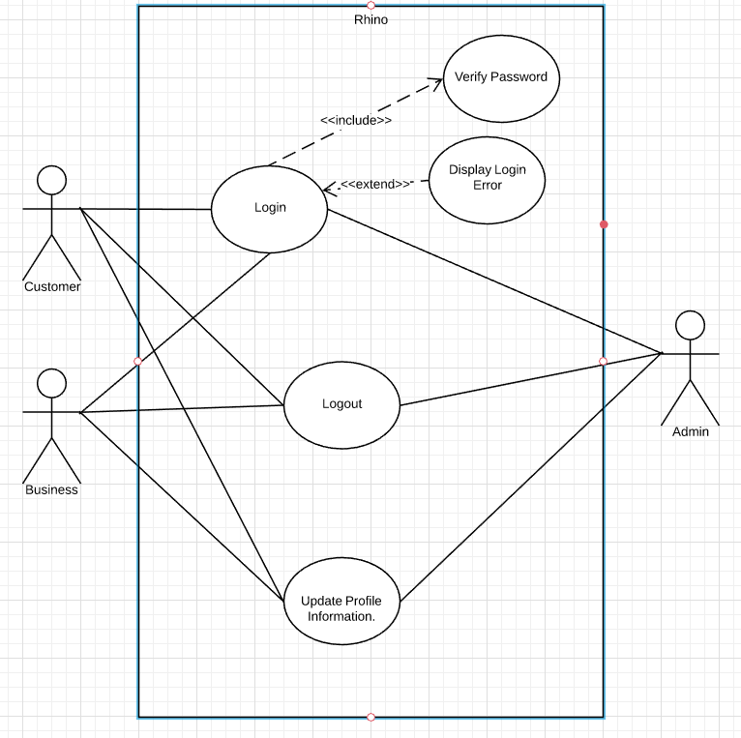

Customer – Business Use Case Diagram

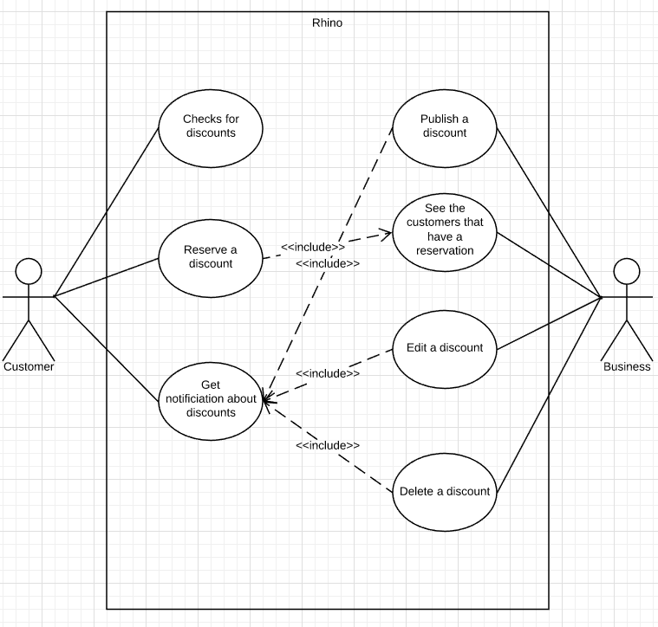

Customer Use Case Diagram

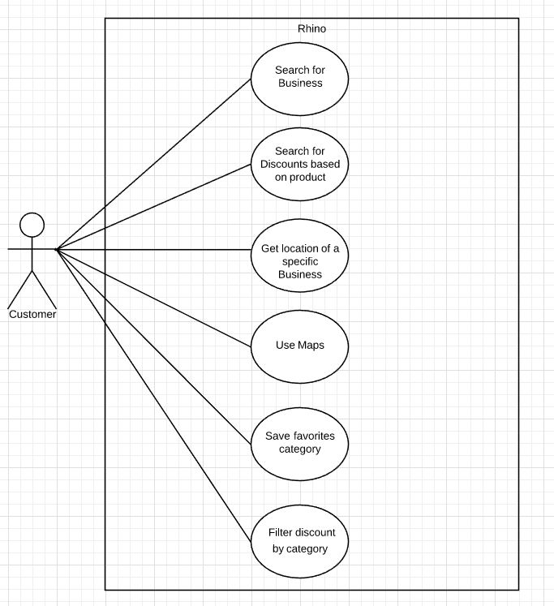

Admin Use Case Diagram

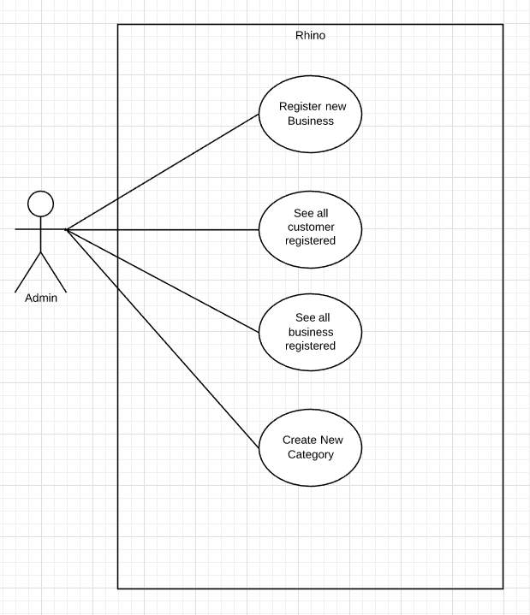

**4.5 Activity Diagram**

Admin Activity Diagram 1

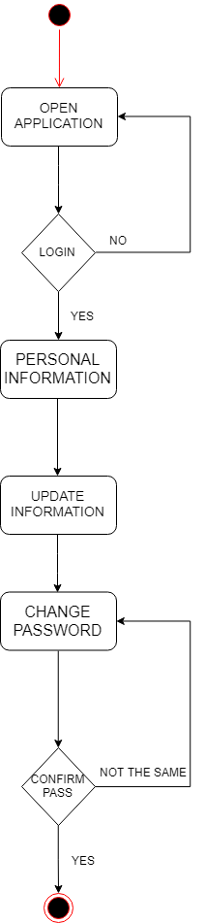

Admin Activity Diagram 2

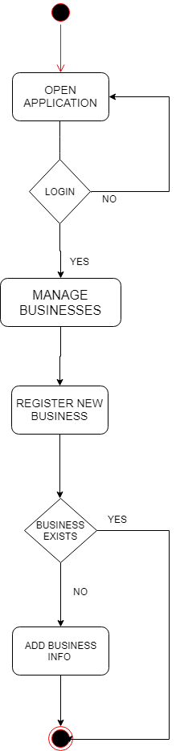

Admin Activity Diagram 3

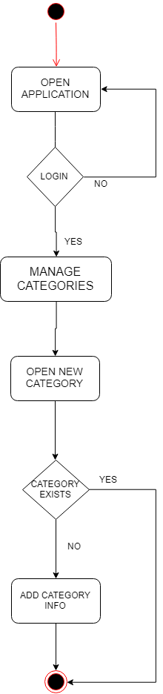

Admin Activity Diagram 4

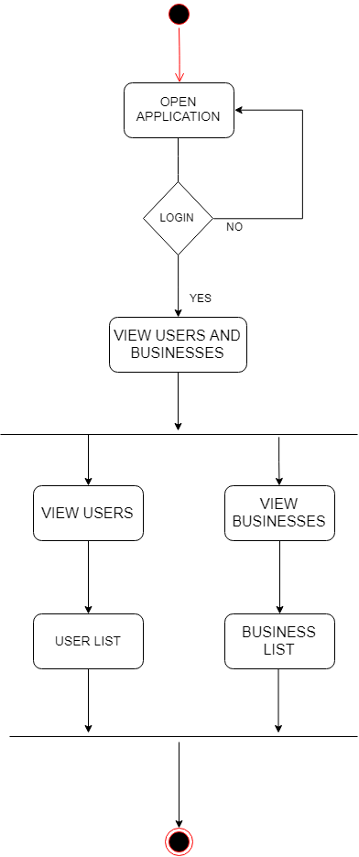

Business Activity Diagram 1

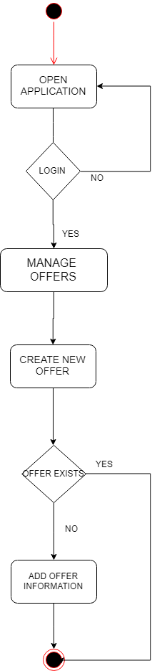

Business Activity Diagram 2

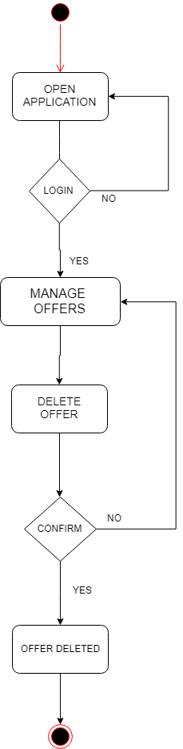

Business Activity Diagram 3

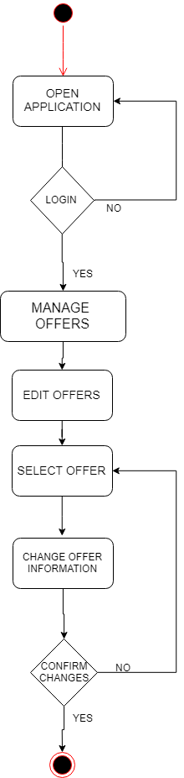

Business Activity Diagram 4

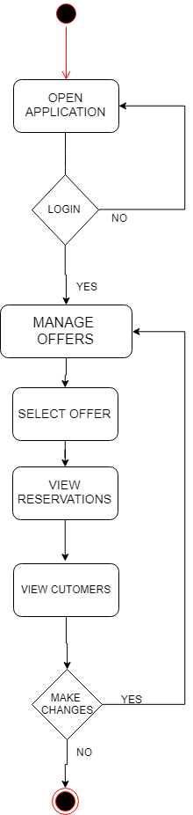

Customer Activity Diagram 1

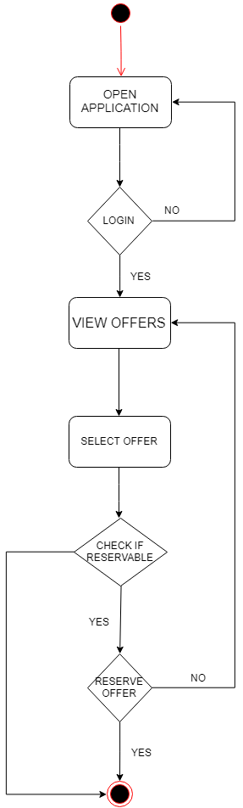

Customer Activity Diagram 2

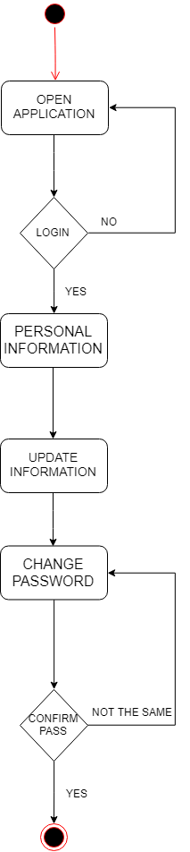

Customer Activity Diagram 3

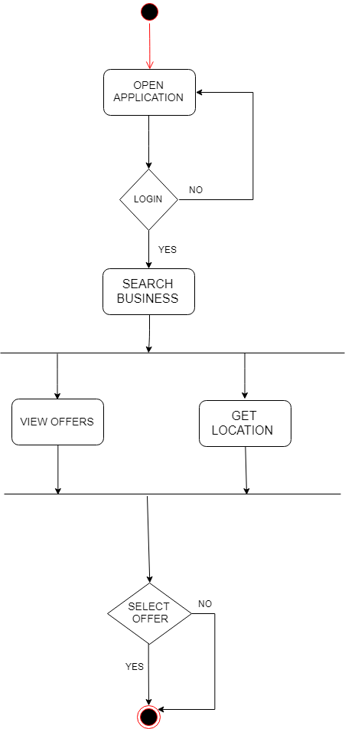

Customer Activity Diagram 4

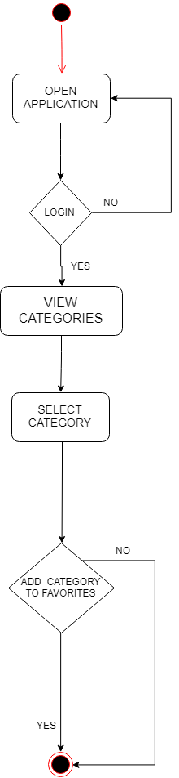

Customer Activity Diagram 5

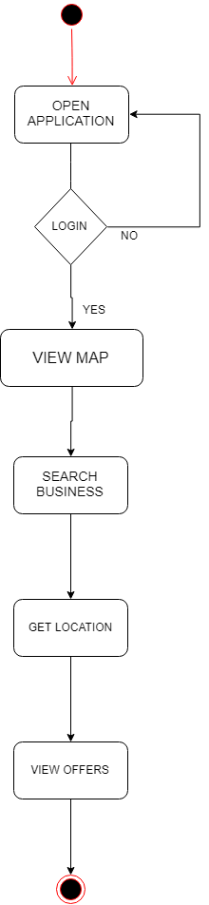

**4.6 State Diagrams**

Admin State Diagram

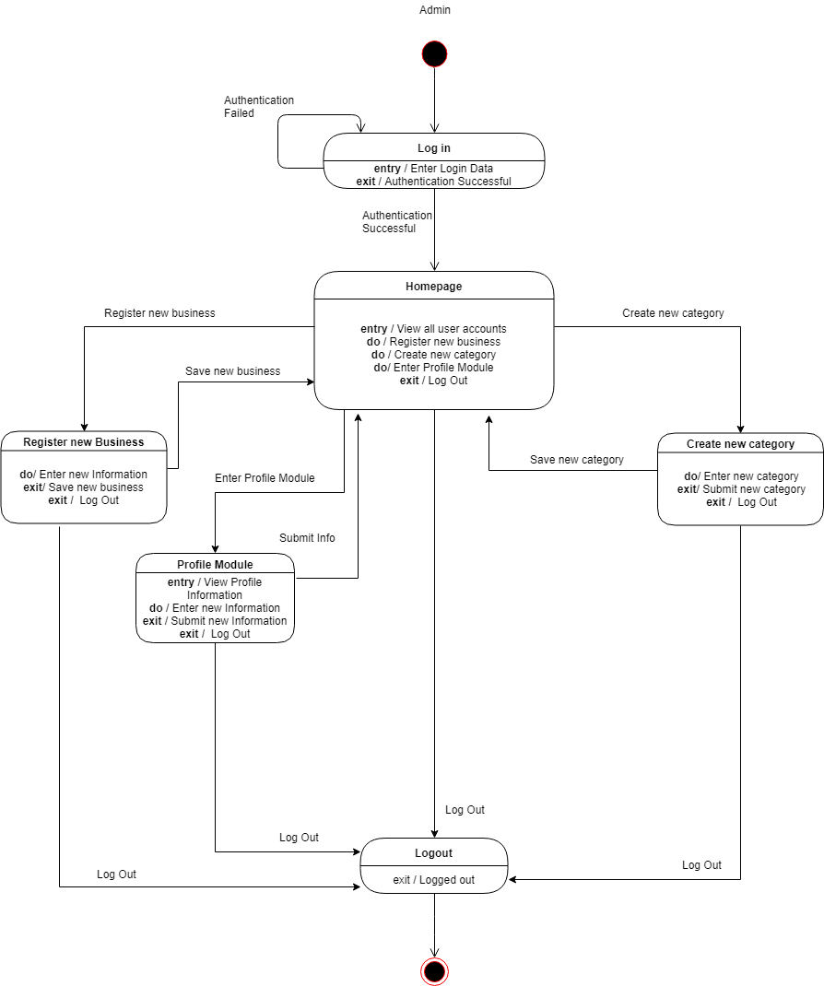

Business State Diagram

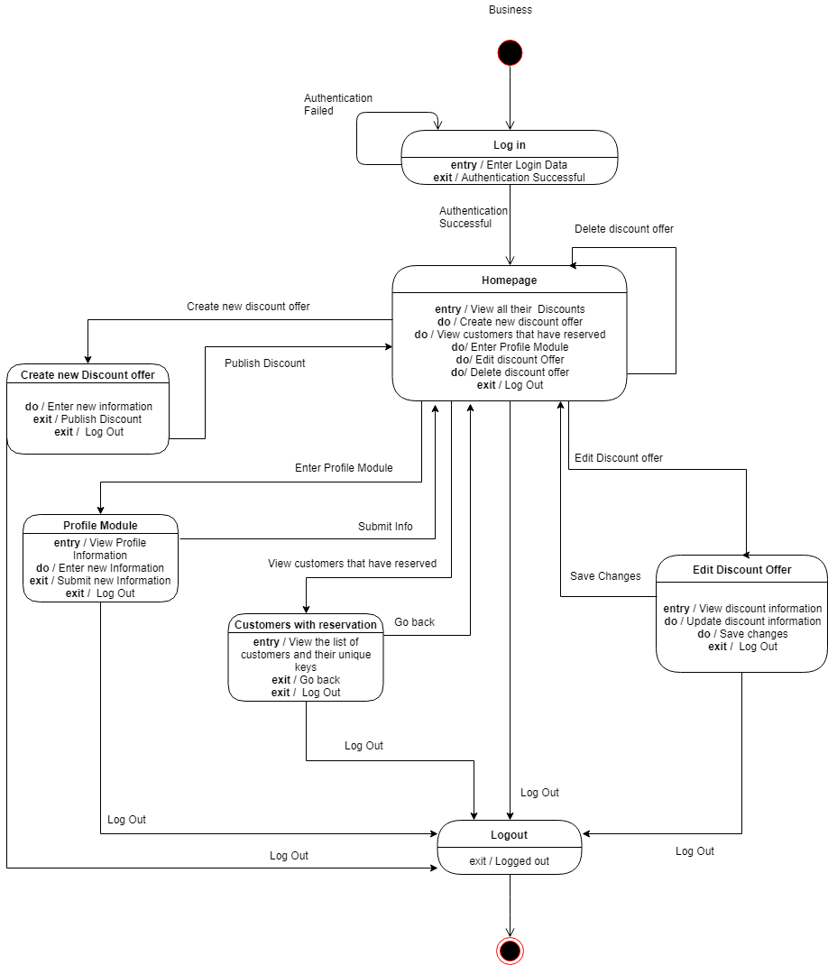

Customer State Diagram

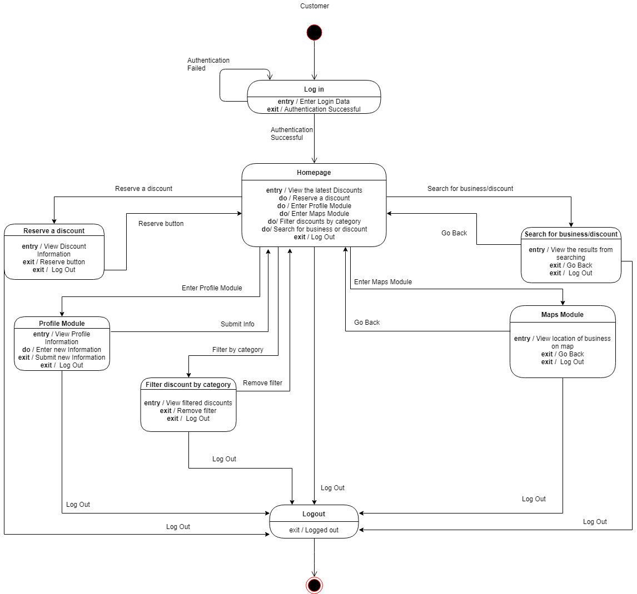

**4.7 Sequence Diagrams**

Admin Sequence Diagram

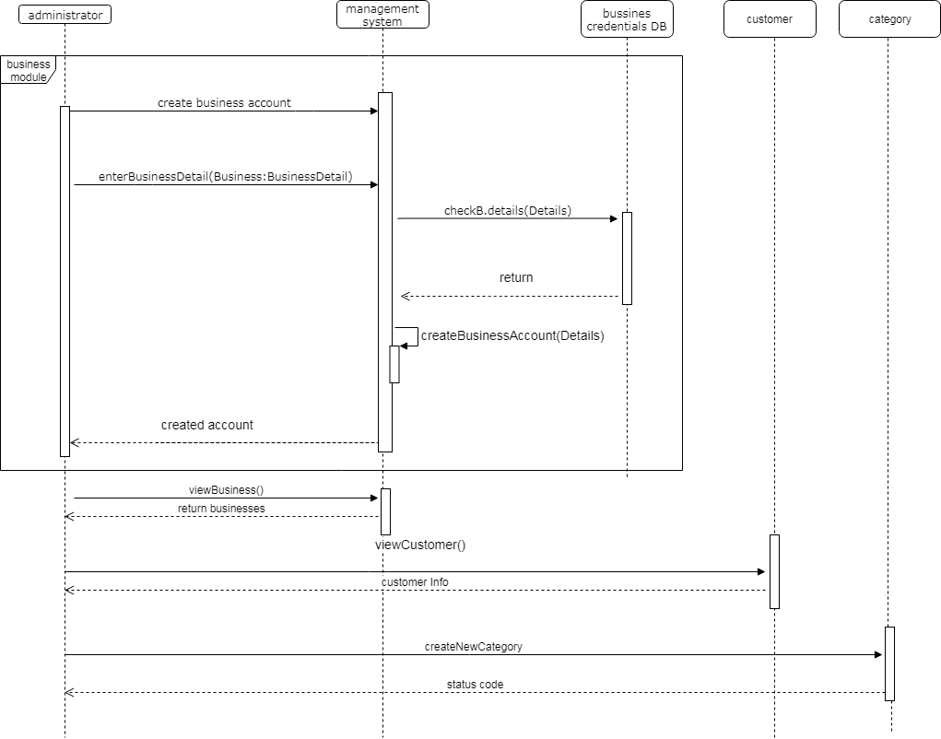

Business Sequence Diagram

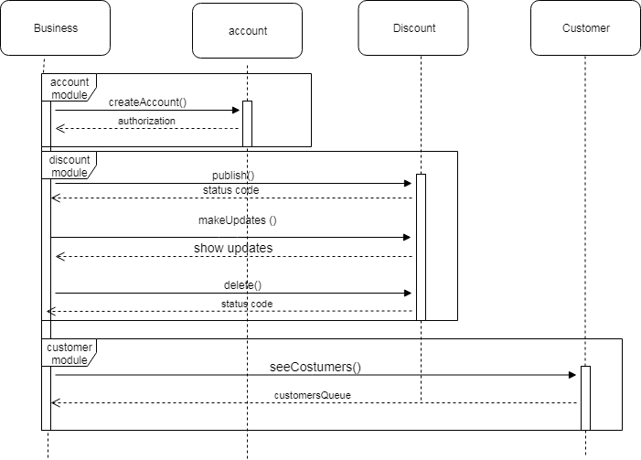

Customer Sequence Diagram

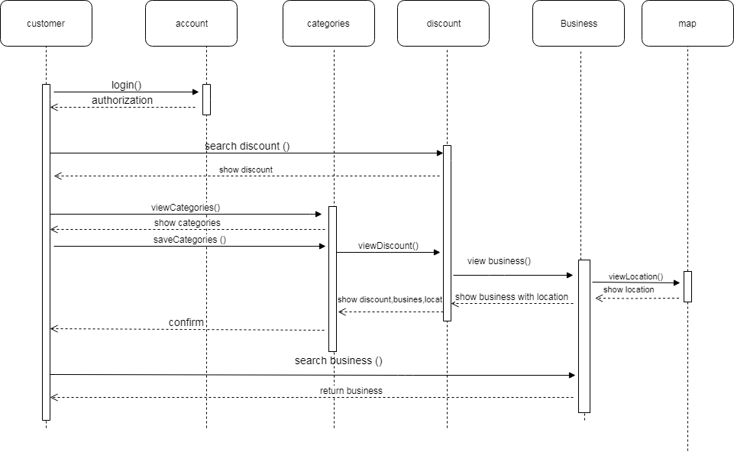

**4.8 Collaboration Diagrams**

Admin Collaboration Diagram

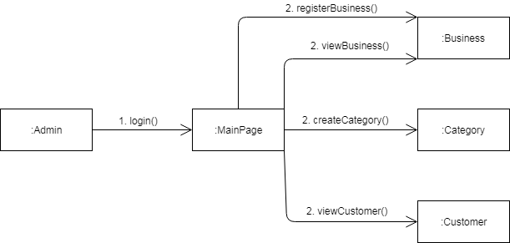

Business Collaboration Diagram

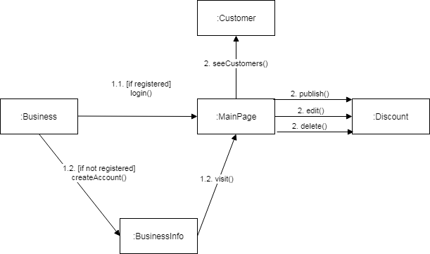

Customer Collaboration Diagram

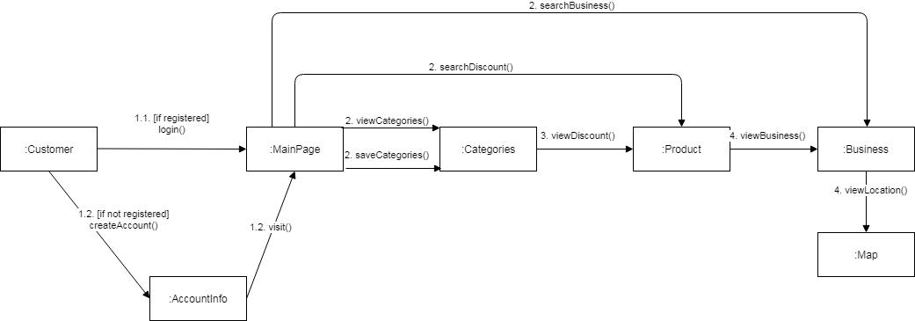

**4.9 Data Flow Diagram**

Data Flow Diagram – Level 2

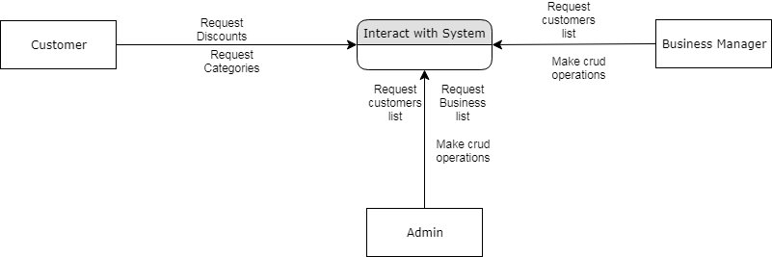

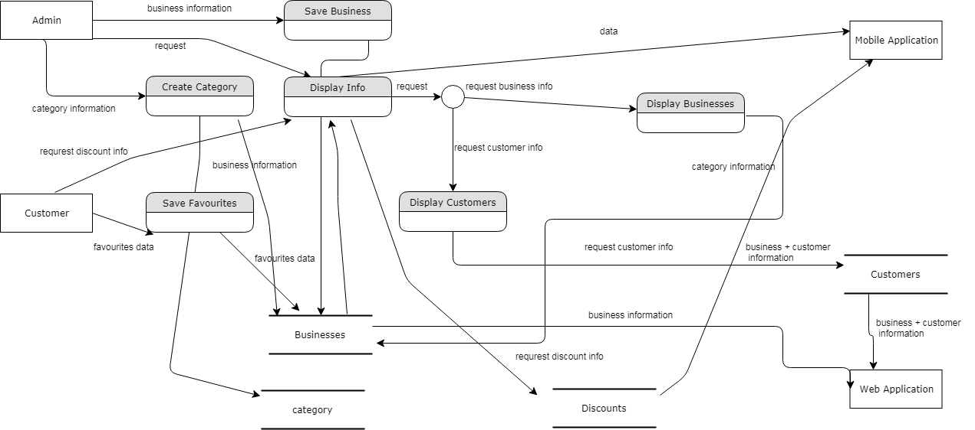

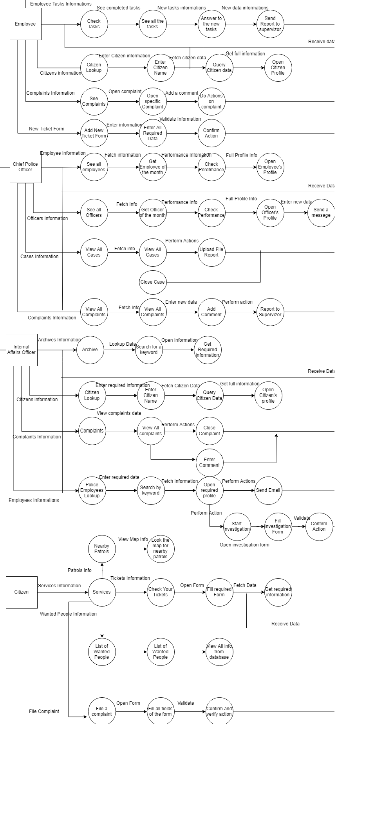

**4.10 ER Diagram**

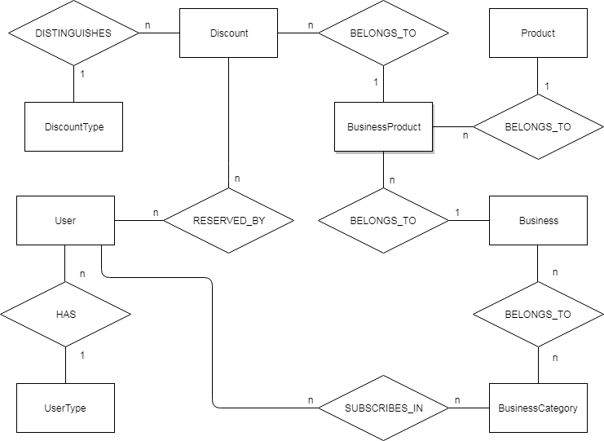

**4.11 DB Schema Diagram**

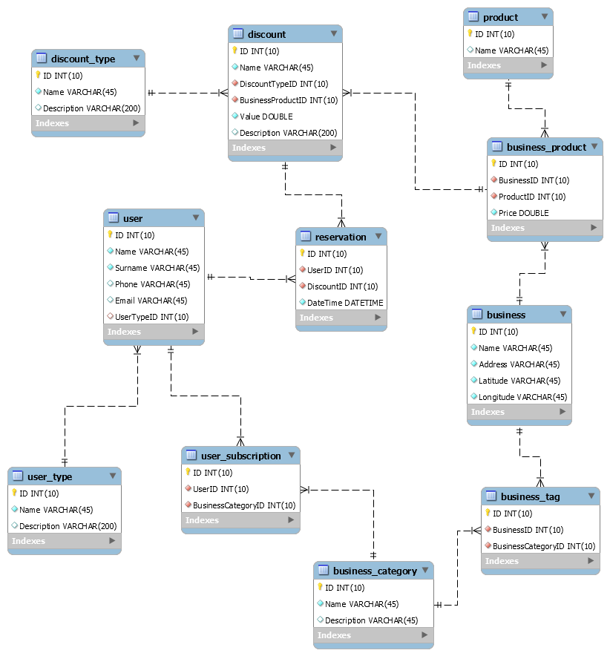

**4.12 Class Diagram**

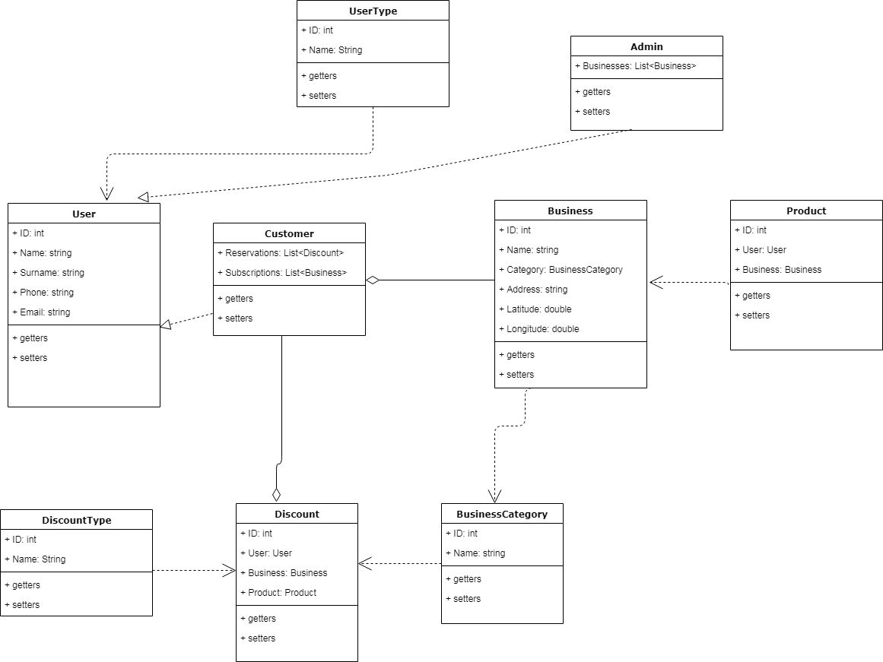

**4.13 Object Diagram**

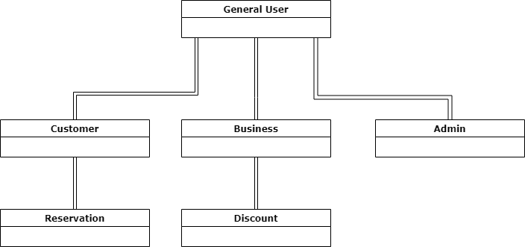

**4.14 Component Diagram**

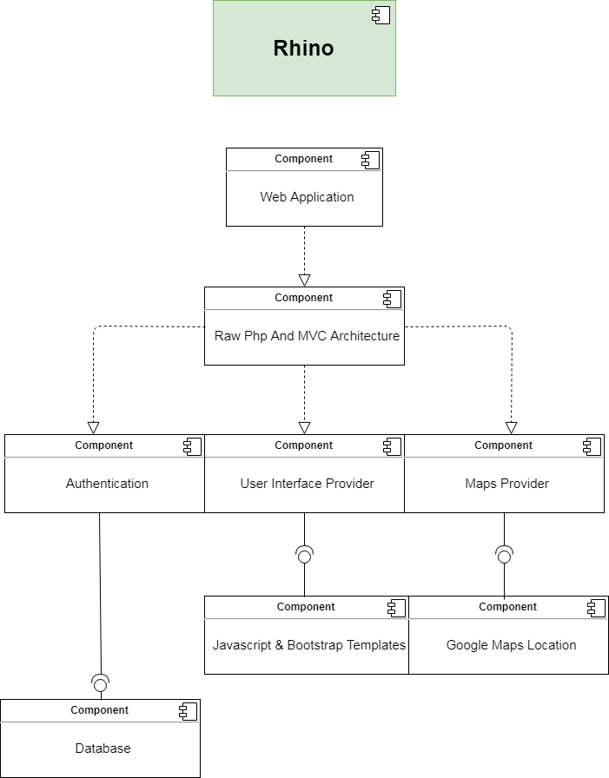

**4.15 Deployment Diagram**

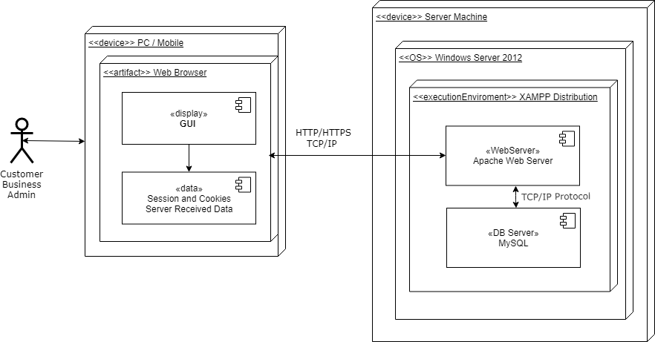

# IMPLEMENTATION TECHNOLOGY

Rhino is a dynamic responsive Web Application. For the creation of this application, Client

Side Scripting and Server-Side Scripting is used. Communication between client and server will take place via HTTP protocol.

For the Client-Side Scripting the following technologies were used extensively:

* HTML 5
* CSS 3
* JavaScript
* Bootstrap
* Ajax
* jQuery

Some ready implemented templates were taken from external sources such as github.com in order to facilitate the process of creating the website and keeping it responsive and well designed. These templates were modified and used accordingly in our project.

For the Server-Side Scripting the following technologies/techniques were used extensively:

* PHP 7
* PDO
* Mysqli
* Htaccess
* MVC architecture
* PHPUnit
* Object Oriented Programming

The model package contains the classes that act as models for holding the main data in our application. Then for every front end page there is a controller that manages this page. This page is known as view. Also there was created a layer for the database and a layer to manage transactions with the database and so for the front end it is only necessary to call these functions from the manager and use their functionality.

For each transaction made with the database the necessary validation is done and there is a layer in our application that does this independently from the other part of the project. Sessions are managed according to the ID of the user that is performing the operations in the system. You cannot login the page without Authentication. The database is hosted for free in remotemysql.com and the host for the application is stud-proj.epoka.edu.al/~aruci16.

# **6. Project Planning**

**Project Name:** Rhino

**Members:** Aleksandros Ruci, Grent Mustafa, Vasjon Done, Elda Hoxhaj, Marko Doga, Ajni Shehu

**Real start and end days**: 05.03.2019 – 07.06.2019

**Estimated start and end days**: 05.03.2019 – 02.06.2019

**Real total days**: 94 days

**Estimated total days**: 87 days

### Task distribution chart

|  |  |  |  |  |
| --- | --- | --- | --- | --- |
| No. | Activity | Duration(days) | Dependencies | Worked |
| 1 | **Proposed topic for the project** | **7** |  | Team |
|  | Discussion about the topic |  |  |  |
| 2 | **Research** | **7** | 1 | Team |
|  | Technologies to implement the projecct |  |  | Team |
|  | Talk with businesses |  |  | Marko Doga |
| 3 | **Requirements Analysis** | **7** | 2 | Aleksandros Ruci/Grent Mustafa |
|  | Product Description |  |  | Aleksandros Ruci/Grent Mustafa |
|  | Functional, Non-functional requirements |  |  | Aleksandros Ruci/Grent Mustafa |
| 4. | Draw Sketches | 5 | 3 | Elda Hoxhaj |
| 5. | **User Scenarios, Use Cases** | **5** | 3 | Grent Mustafa |
|  | **Behavioral Diagrams** |  |  |  |
| 6. | Use Cases Diagrams | 5 | 3,4 | Grent Mustafa |
| 7. | Activity Diagrams | 5 | 6 | Marko Doga |
| 8. | State Diagrams | 5 | 6 | Grent Musafa |
| 9. | Sequence Diagrams | 5 | 7,8 | Elda Hoxhaj |
| 10. | Collaboration Diagrams | 4 | 9 | Vasjon Done |
| 11. | **Entity Relation Diagram** | 4 | 5,6 | Aleksandros Ruci |
| 12. | **Data Flow Diagram** | 4 | 5,6 | Aleksandros Ruci |
|  | **Structural Diagrams** | **5** |  |  |
| 13. | Class Diagram | 3 | 10 | Aleksandros Ruci |
| 14. | Object Diagram | 4 | 13 | Grent Mustafa |
| 15. | Component Diagram | 4 | 14 | Vasjon Done |
| 16. | Deployment Diagram | 2 | 15 | Ajni Shehu |
| 17. | Web App Coding | 11 | 6, 11,12, 13, 16 | Aleksandros Ruci, Grent Mustafa, Vasjon Done |
| 18. | Testing | 8 | 17 | Aleksandros Ruci, Grent Mustafa, Vasjon Done,  Ajni Sheu |
| 19. | Documentation | 12 | 18 | Aleksandros Ruci, Grent Mustafa |

### Network analysis

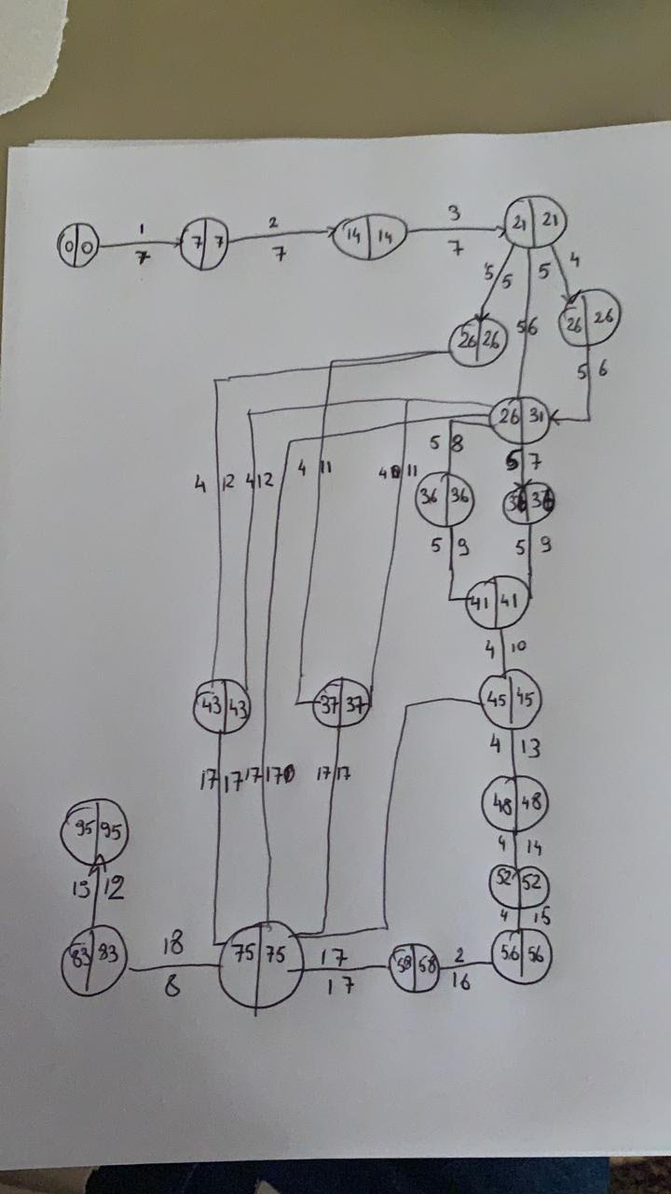

### 6.1.3 Gantt Chart

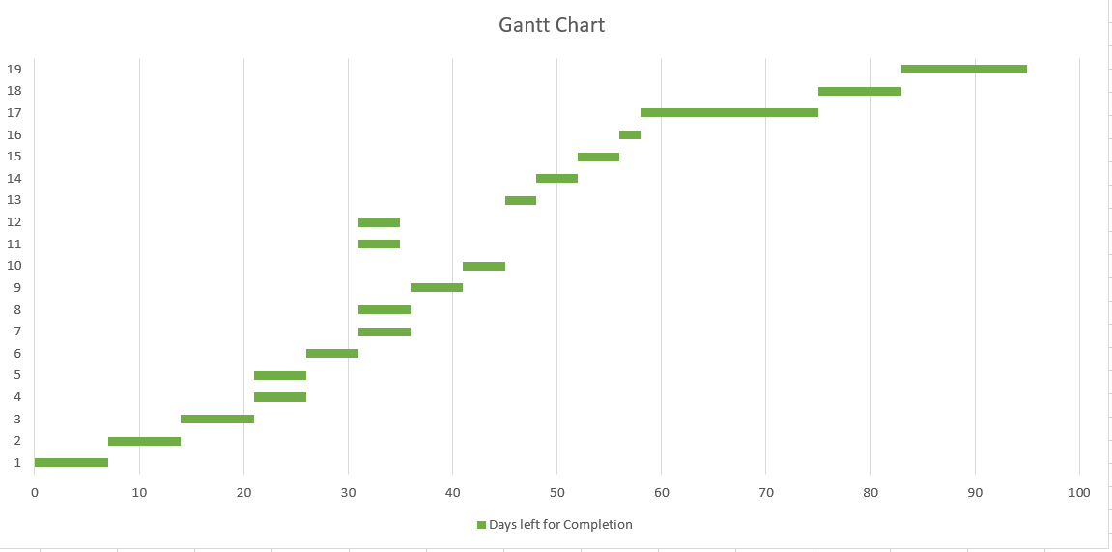

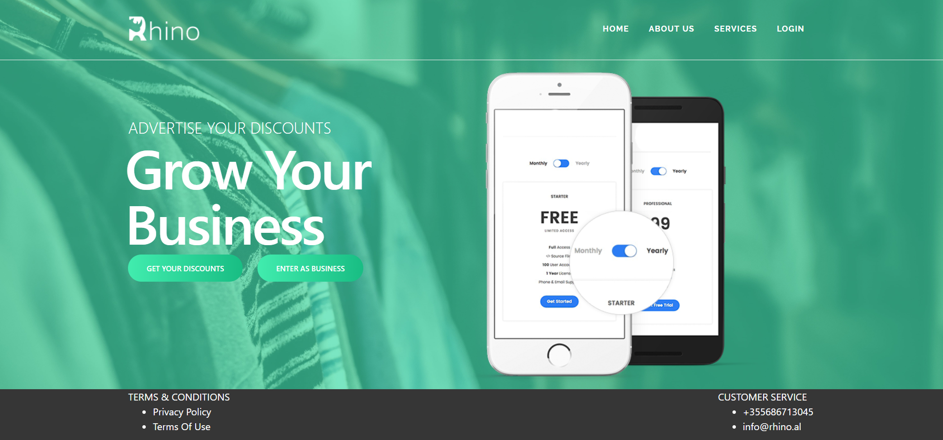

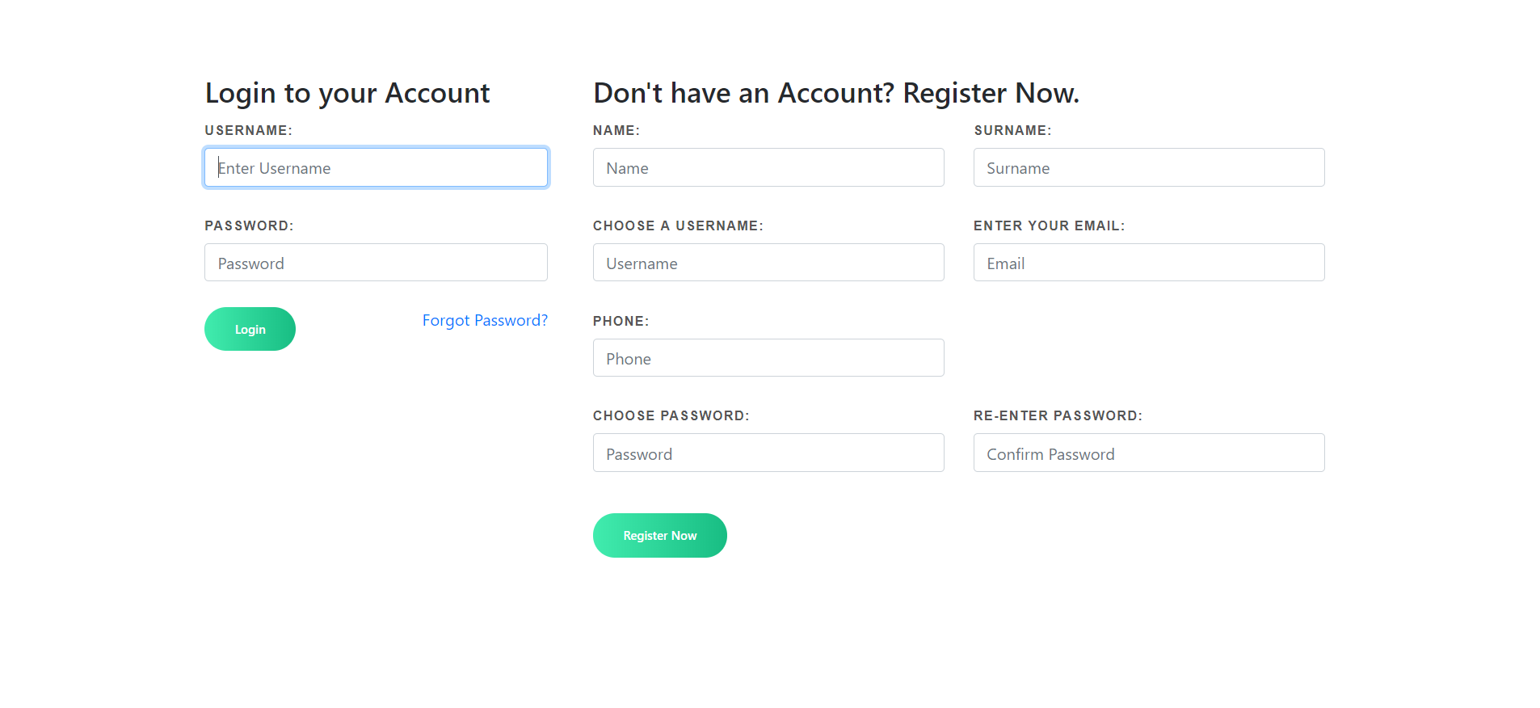

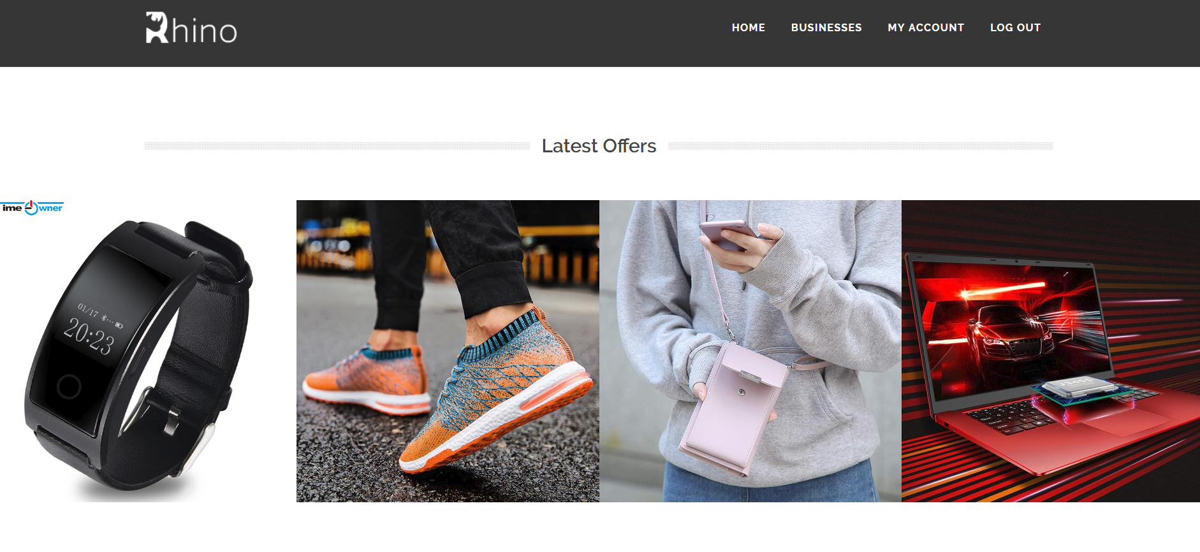

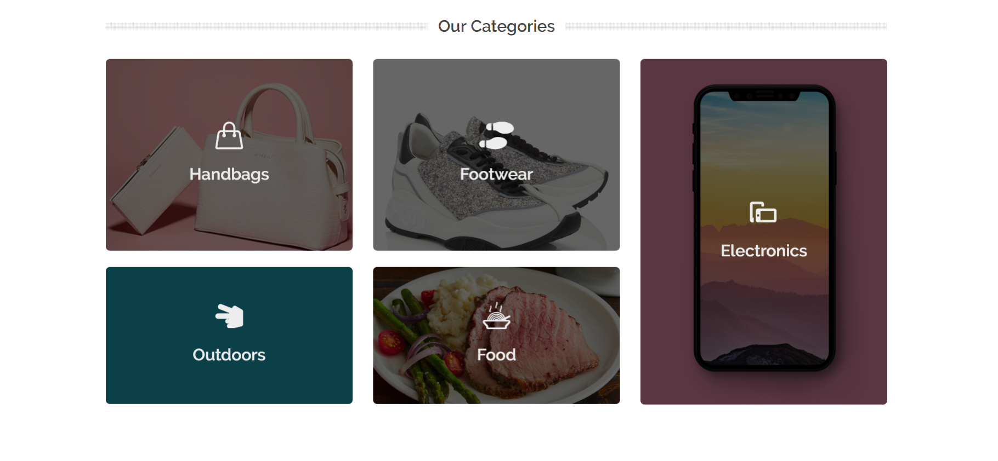

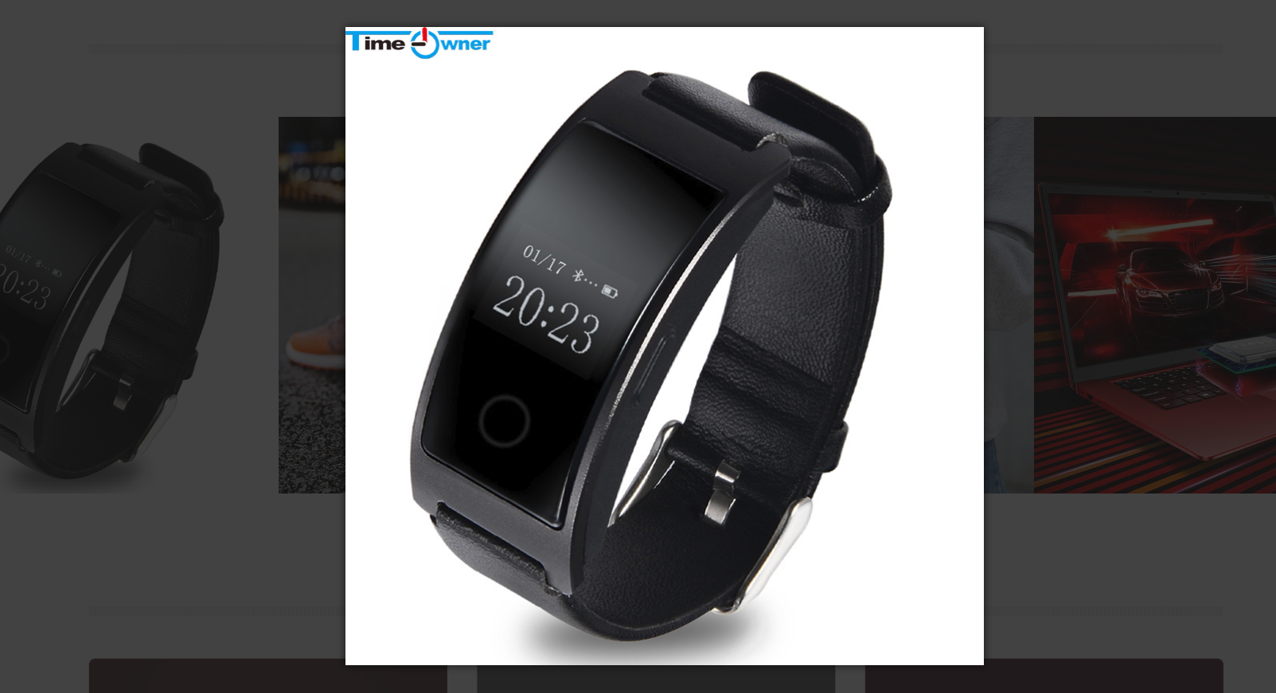

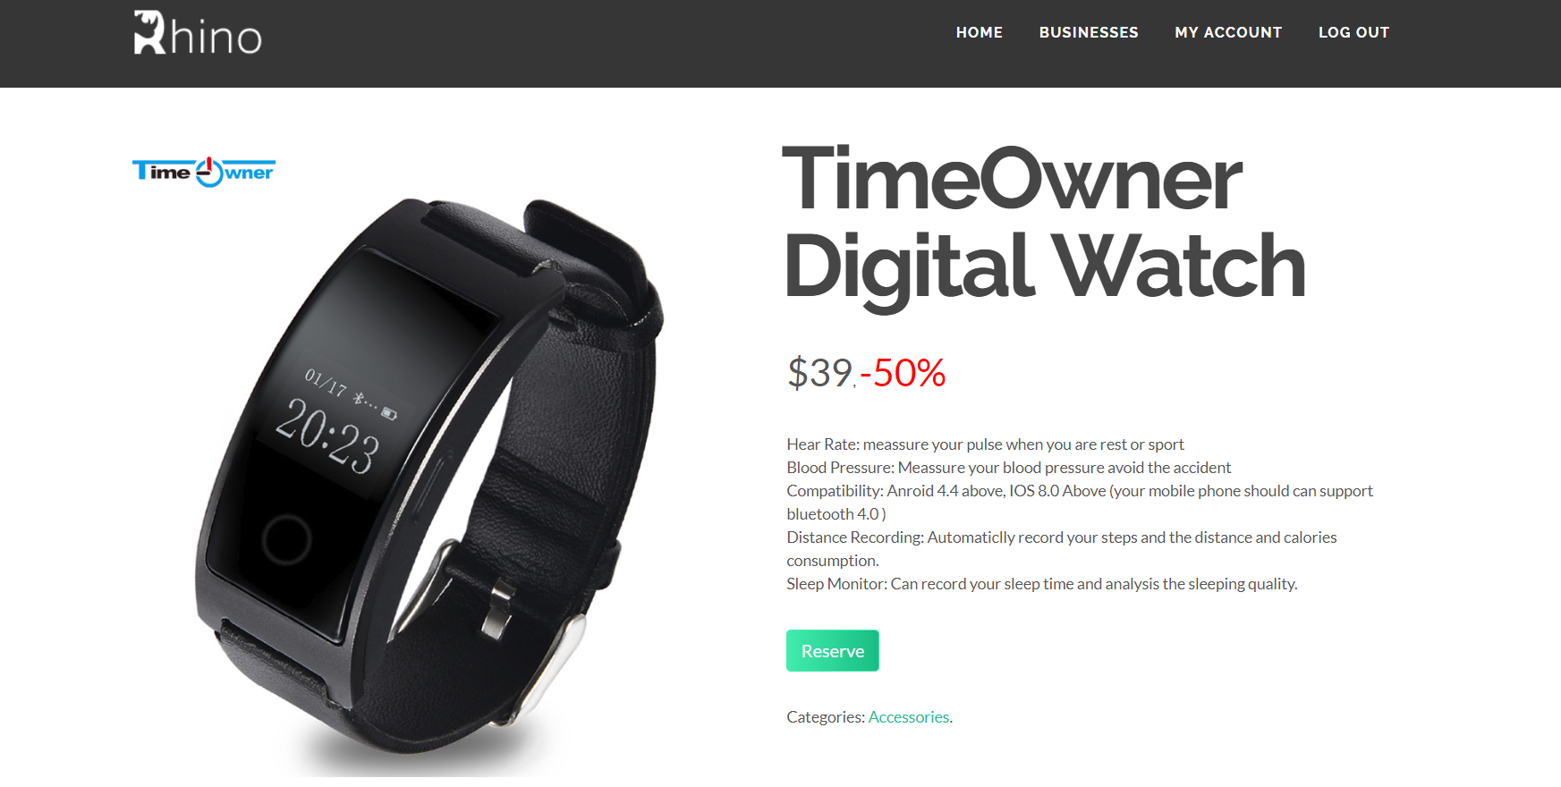

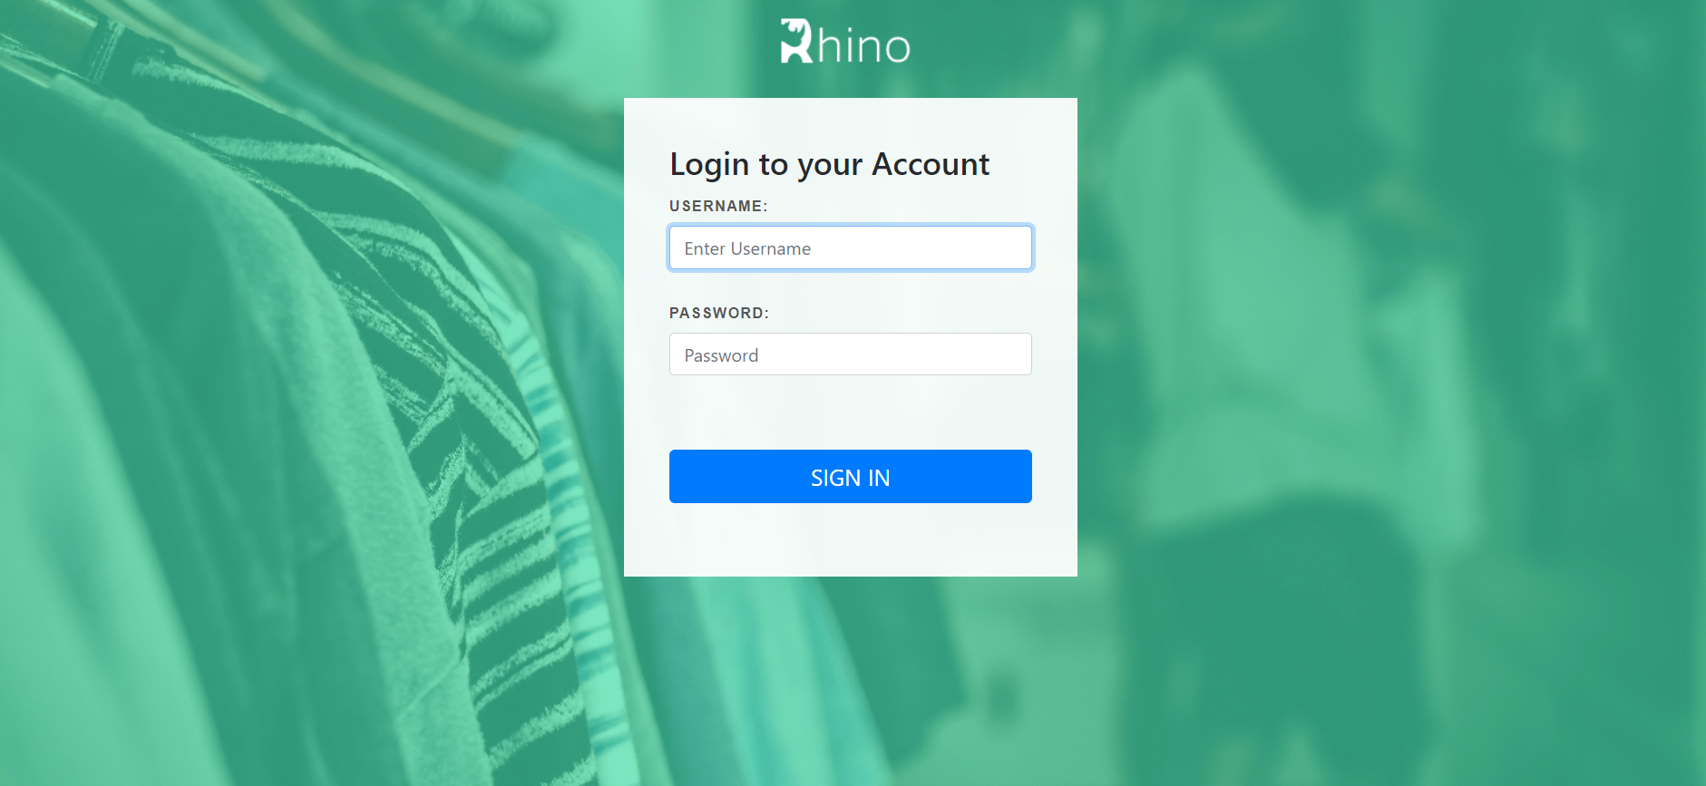

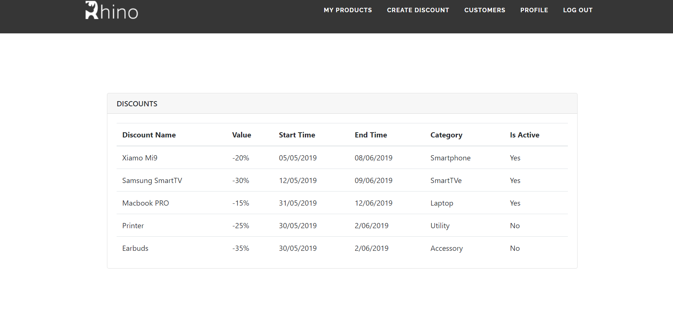

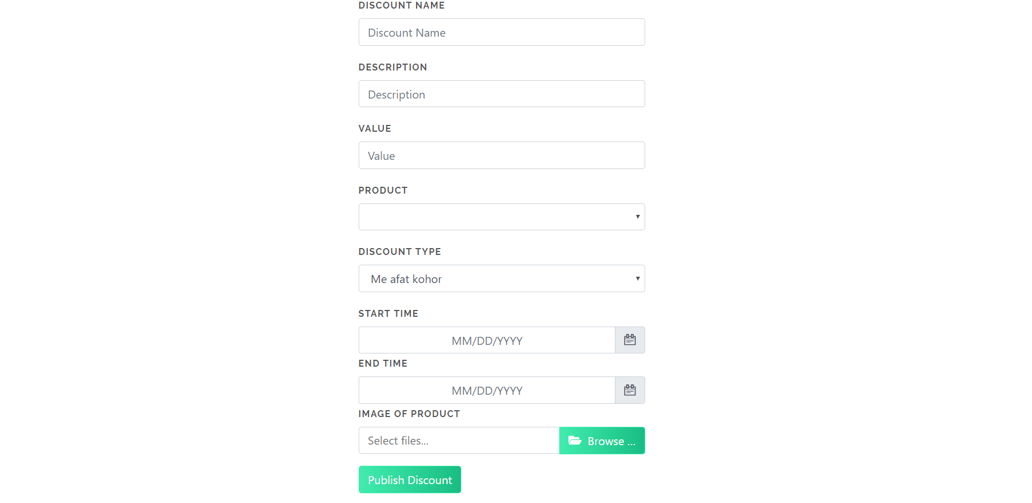

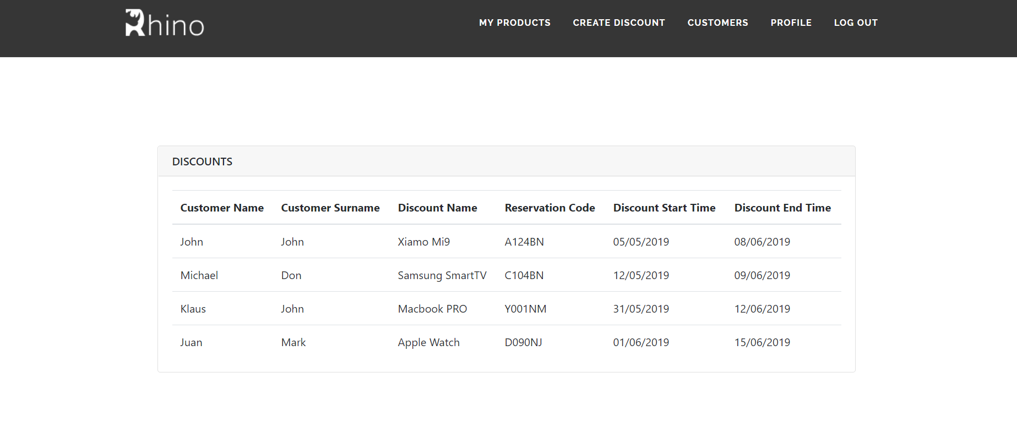

**APPENDIX**

The appendixes are not always considered part of the actual Requirements Specification and are not always necessary. They may include

* Sample input/output formats, descriptions of cost analysis studies, or results of user surveys;
* Supporting or background information that can help the readers of the Requirements Specification;
* A description of the problems to be solved by the system;
* Special packaging instructions for the code and the media to meet security, export, initial loading, or other requirements.

When appendixes are included, the Requirements Specification should explicitly state whether or not the appendixes are to be considered part of the requirements.

Sketches

Mobile Application - Opened For the first time

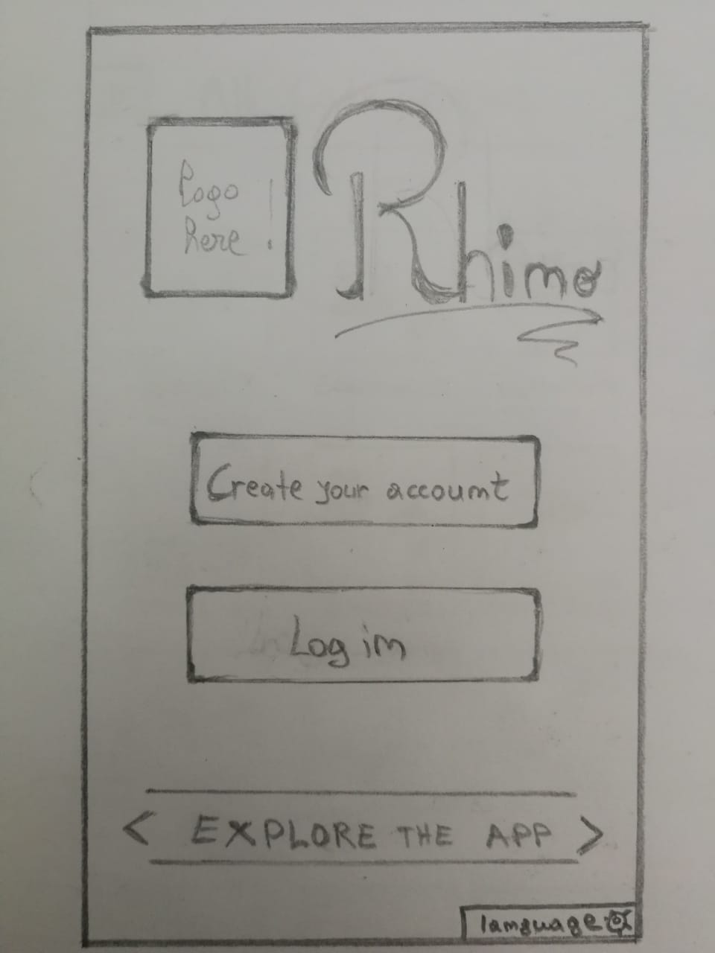

Mobile Application - Home page

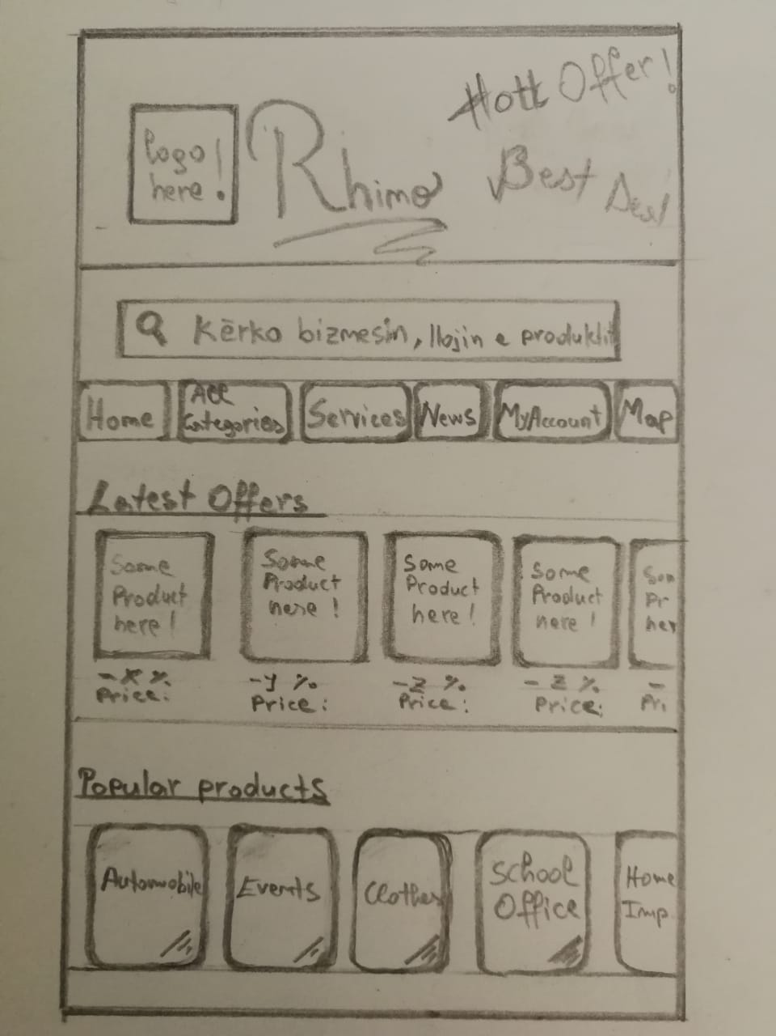

Mobile Application – User’s account

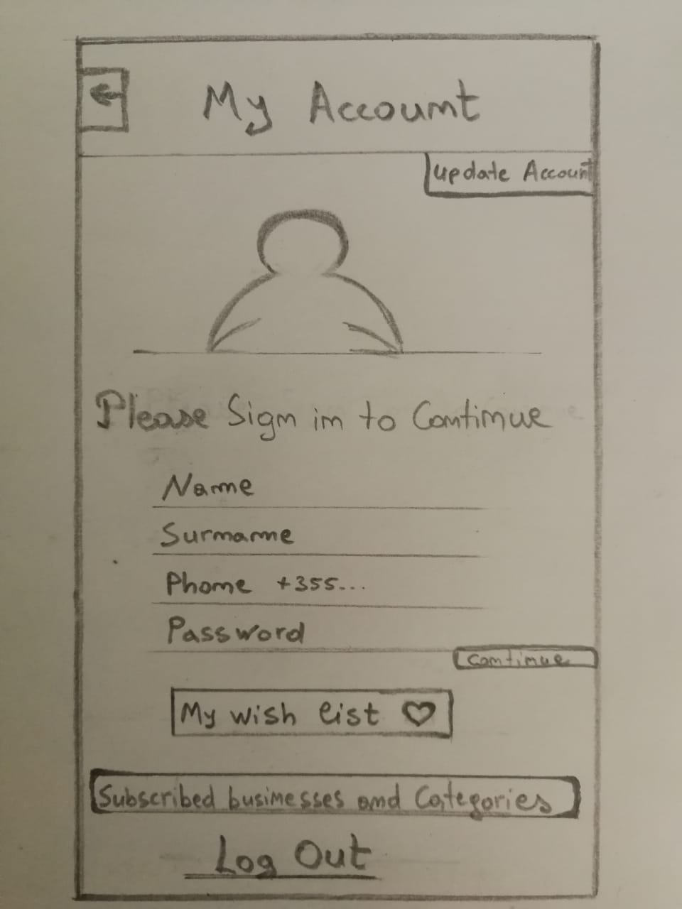

Mobile Application – Business Categories

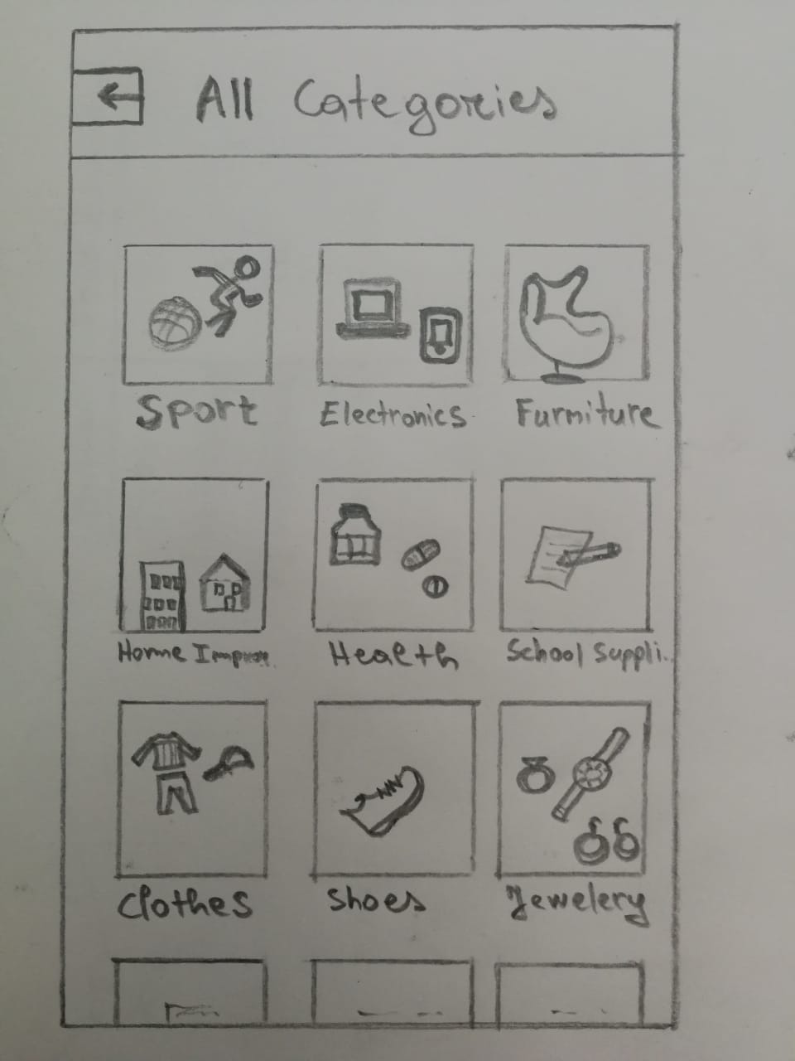

Mobile Application - Services

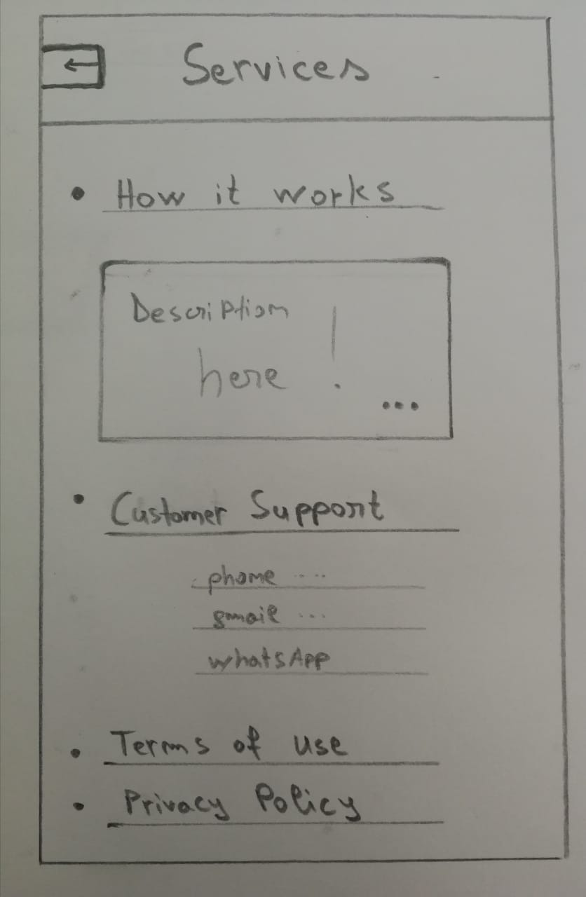

Mobile Application - Maps

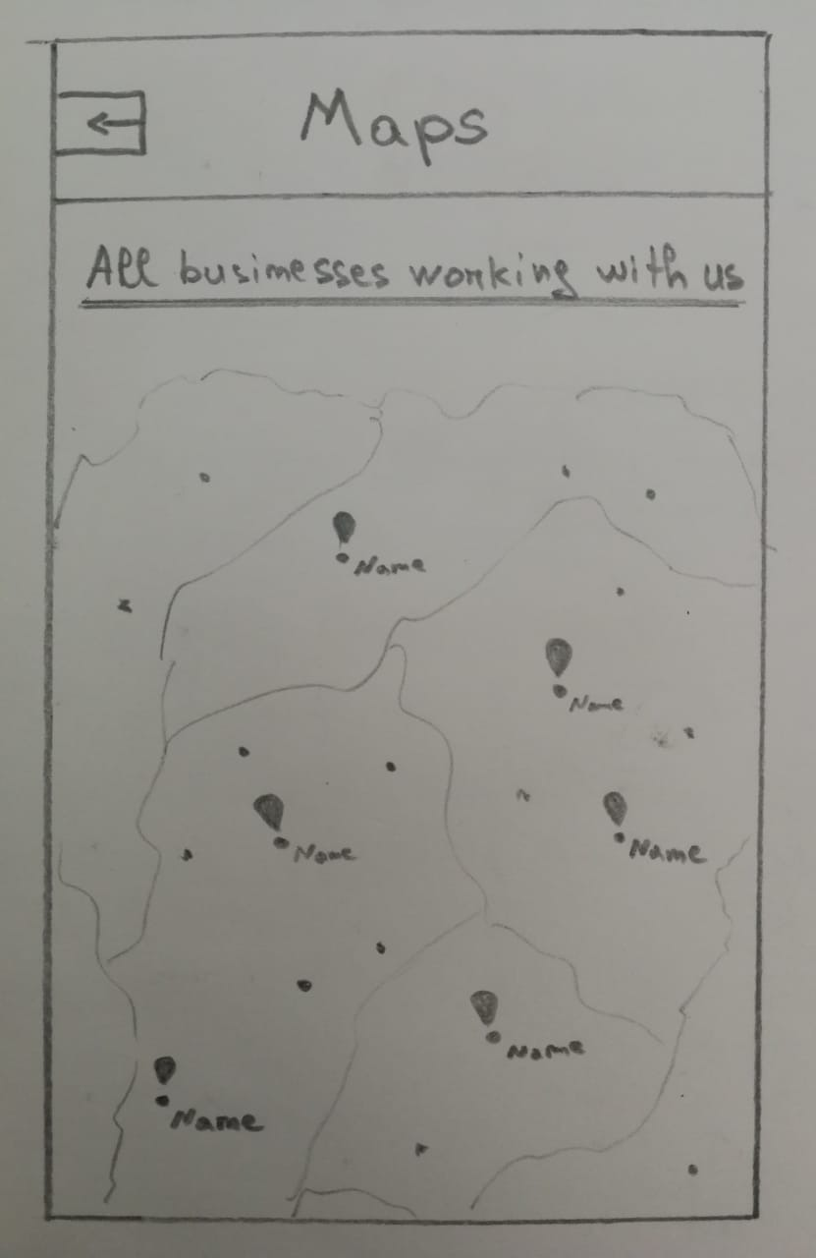

Web Application – First page

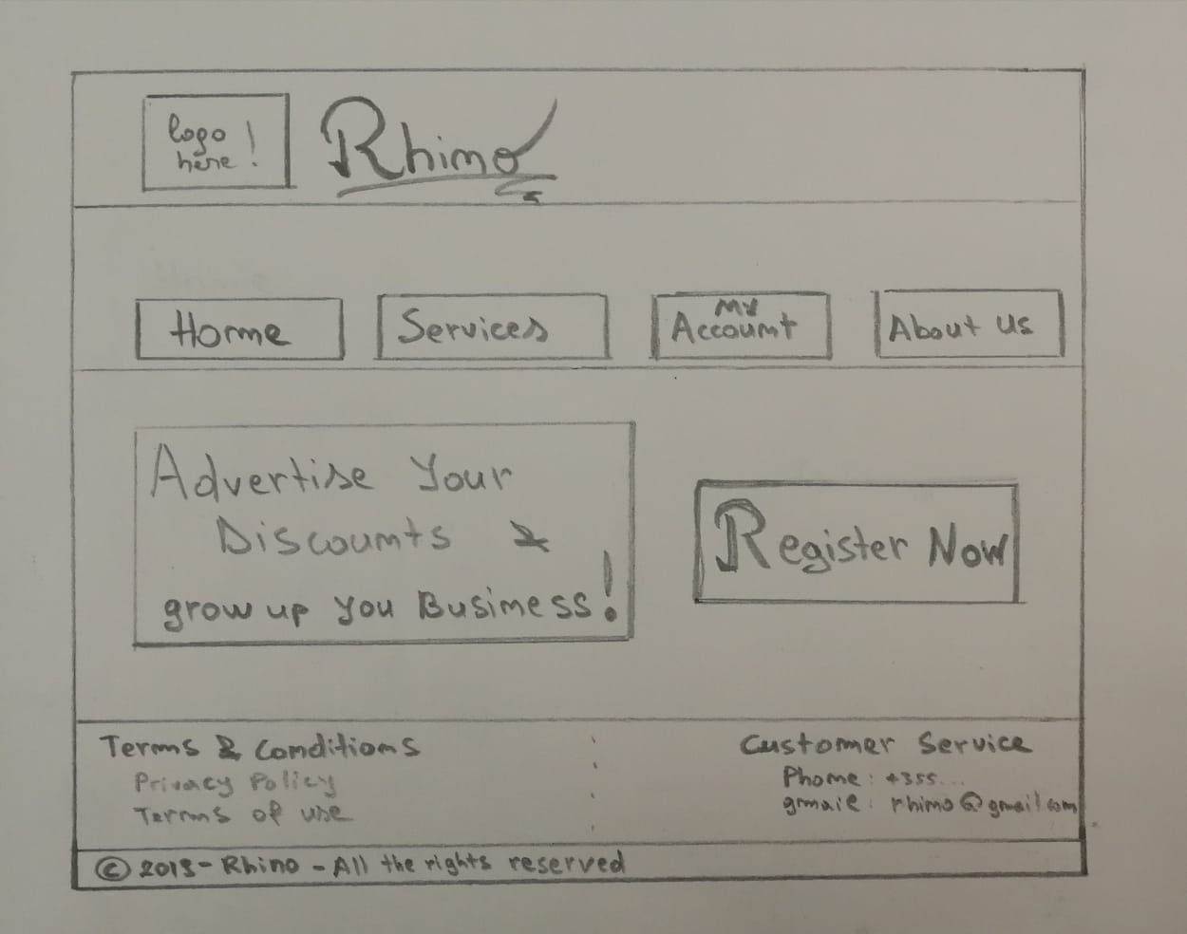

Web Application – Business Registration

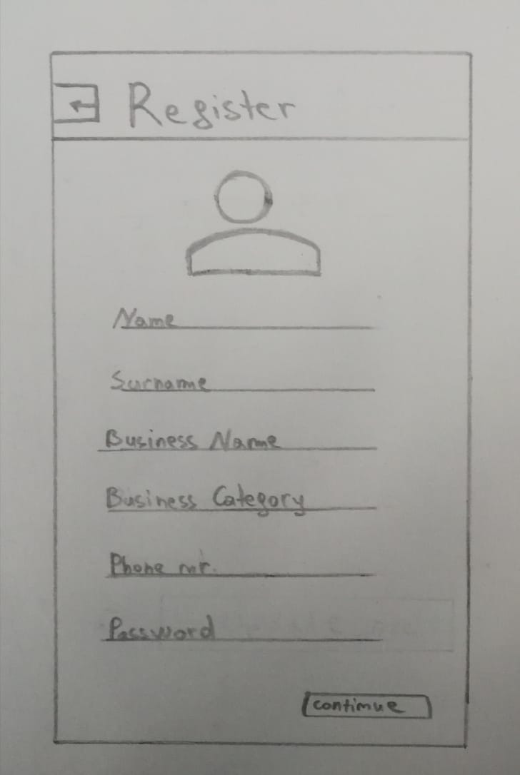

Web Application - Business posting new discount

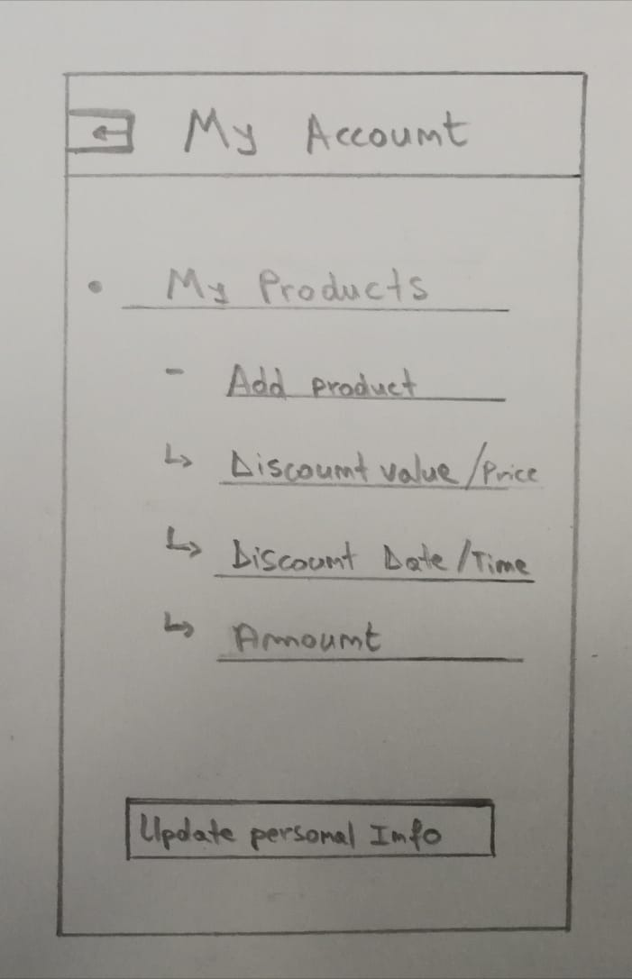

Web Application – Services

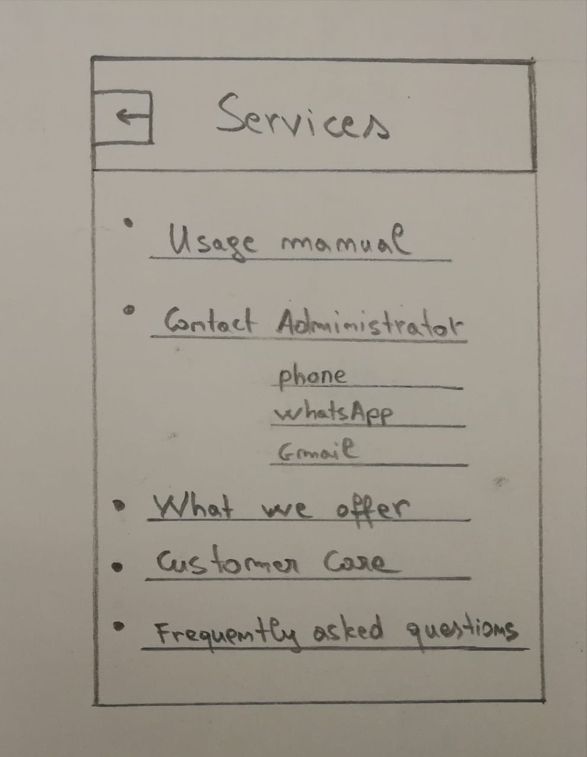

1. Definitions, Acronyms, and Abbreviations

Define all terms, acronyms, and abbreviations used in this document.

1. References

List all the documents and other materials referenced in this document.

1. Requirements Traceability Matrix

The following trace matrix examples show one possible use of naming standards for deliverables (FunctionalArea-DocType-NN). The number has no other meaning than to keep the documents unique. For example, the Bargaining Unit Assignment Process Flow would be BUA-PF-01.

For example (1):

| **Business Requirement** | **Area** | **Deliverables** | **Status** |
| --- | --- | --- | --- |
| BR_LR_01  The system should validate the relationship between Bargaining Unit/Location and Job Class.---Comments: Business Process = "Assigning a Bargaining Unit to an Appointment" (Priority 1) | BUA | BUA-CD-01  Assign BU Conceptual Design | Accepted |
| BUA-PF-01  Derive Bargaining Unit-Process Flow Diagram | Accepted |
| BUA-PF-01  Derive Bargaining Unit-Process Flow Diagram | Accepted |
| BR_LR_09  The system should provide the capability for the Labor Relations Office to maintain the job class/union relationship.---Comments: Business Process = "Maintenance" (Priority 1) | BUA | BUA-CD-01  Assign BU Conceptual Design | Accepted |
| BUA-PF-02  BU Assignment Rules Maint Process Flow Diagram | ReadyForReview |

For example (2):

| **BizReqID** | **Pri** | **Major Area** | **DevTstItems DelivID** | **Deliv Name** | **Status** |
| --- | --- | --- | --- | --- | --- |
| BR_LR_01 | 1 | BUA | BUA-CD-01 | Assign BU Conceptual Design | Accepted |
| BR_LR_01 | 1 | BUA | BUA-DS-02 | Bargaining Unit Assignment DB Modification Description | Accepted |
| BR_LR_01 | 1 | BUA | BUA-PF-01 | Derive Bargaining Unit-Process Flow Diagram | Accepted |
| BR_LR_01 | 1 | BUA | BUA-UCD-01 | BU Assign LR UseCase Diagram | ReadyForReview |
| BR_LR_01 | 1 | BUA | BUA-UCT-001 | BU Assignment by PC UseCase - Add Appointment and Derive UBU | Reviewed |
| BR_LR_01 | 1 | BUA | BUA-UCT-002 | BU Assignment by PC UseCase - Add Appointment (UBU Not Found) | Reviewed |
| BR_LR_01 | 1 | BUA | BUA-UCT-006 | BU Assignment by PC UseCase - Modify Appointment (Removed UBU) | Reviewed |
| BR_LR_09 | 1 | BUA | BUA-CD-01 | Assign BU Conceptual Design | Accepted |
| BR_LR_09 | 1 | BUA | BUA-DS-02 | Bargaining Unit Assignment DB Modification Description | Accepted |
| BR_LR_09 | 1 | BUA | BUA-PF-02 | BU Assignment Rules Maint Process Flow Diagram | Accepted |
| BR_LR_09 | 1 | BUA | BUA-UCD-03 | BU Assign Rules Maint UseCase Diagram | Reviewed |
| BR_LR_09 | 1 | BUA | BUA-UCT-045 | BU Assignment Rules Maint: Successfully Add New Assignment Rule | Reviewed |
| BR_LR_09 | 1 | BUA | BUA-UCT-051 | BU Assignment Rules MaintUseCase: Modify Rule | Reviewed |
| BR_LR_09 | 1 | BUA | BUA-UCT-053 | BU Assignment Rules MaintUseCase - Review Assignment Rules | Reviewed |
| BR_LR_09 | 1 | BUA | BUA-UCT-057 | BU Assignment Rules MaintUseCase: Inactivate Last Rule for a BU | Reviewed |
| BR_LR_09 | 1 | BUA | BUA-UI-02 | BU AssignRules Maint UI Mockups | ReadyForReview |
| BR_LR_09 | 1 | BUA | BUA-TC-021 | BU Assignment Rules Maint TestCase: Add New Rule (Associated Job Class Does Not Exist) - Success | ReadyForReview |
| BR_LR_09 | 1 | BUA | BUA-TC-027 | BU Assignment Rules Maint TestCase: Modify Rule - Success | ReadyForReview |
| BR_LR_09 | 1 | BUA | BUA-TC-035 | BU Assignment Rules Maint TestCase: Add New Rule (Associated Job Class Does Not Exist) - Error Condition | ReadyForReview |
| BR_LR_09 | 1 | BUA | BUA-TC-049 | BU Assignment Rules Maint TestCase: Modify Rule - Error Condition | ReadyForReview |

For example (3):

| **BizReqID** | **CD01** | **CD02** | **CD03** | **CD04** | **UI01** | **UI02** | **UCT01** | **UCT02** | **UCT03** | **TC01** | **TC02** | **TC03** | **TC04** |
| --- | --- | --- | --- | --- | --- | --- | --- | --- | --- | --- | --- | --- | --- |
| BR_LR_01 |  |  | X |  | X |  | X |  |  | X |  | X |  |
| BR_LR_09 | X |  |  | X |  | X |  |  | X |  | X |  | X |
| BR_LR_10 | X |  |  | X |  |  |  |  | X |  | X |  |  |
| BR_LR_11 |  | X |  |  |  |  |  |  |  |  |  |  |  |

1. Organizing the Requirements

This section is for information only as an aid in preparing the requirements document.

Detailed requirements tend to be extensive. Give careful consideration to your organization scheme. Some examples of organization schemes are described below:

By System Mode

Some systems behave quite differently depending on the mode of operation. For example, a control system may have different sets of functions depending on its mode: training, normal, or emergency.

By User Class

Some systems provide different sets of functions to different classes of users. For example, an elevator control system presents different capabilities to passengers, maintenance workers, and fire fighters.

By Objects

Objects are real-world entities that have a counterpart within the system. For example, in a patient monitoring system, objects include patients, sensors, nurses, rooms, physicians, medicines, etc. Associated with each object is a set of attributes (of that object) and functions (performed by that object). These functions are also called services, methods, or processes. Note that sets of objects may share attributes and services. These are grouped together as classes.

By Feature

A feature is an externally desired service by the system that may require a sequence of inputs to affect the desired result. For example, in a telephone system, features include local call, call forwarding, and conference call. Each feature is generally described in a sequence of stimulus-response pairs, and may include validity checks on inputs, exact sequencing of operations, responses to abnormal situations, including error handling and recovery, effects of parameters, relationships of inputs to outputs, including input/output sequences and formulas for input to output.

By Stimulus

Some systems can be best organized by describing their functions in terms of stimuli. For example, the functions of an automatic aircraft landing system may be organized into sections for loss of power, wind shear, sudden change in roll, vertical velocity excessive, etc.

By Response

Some systems can be best organized by describing all the functions in support of the generation of a response. For example, the functions of a personnel system may be organized into sections corresponding to all functions associated with generating paychecks, all functions associated with generating a current list of employees, etc.

By Functional Hierarchy

When none of the above organizational schemes prove helpful, the overall functionality can be organized into a hierarchy of functions organized by common inputs, common outputs, or common internal data access. Data flow diagrams and data dictionaries can be used to show the relationships between and among the functions and data.

Additional Comments

Whenever a new Requirements Specification is contemplated, more than one of the organizational techniques given above may be appropriate. In such cases, organize the specific requirements for multiple hierarchies tailored to the specific needs of the system under specification.

There are many notations, methods, and automated support tools available to aid in the documentation of requirements. For the most part, their usefulness is a function of organization. For example, when organizing by mode, finite state machines or state charts may prove helpful; when organizing by object, object-oriented analysis may prove helpful; when organizing by feature, stimulus-response sequences may prove helpful; and when organizing by functional hierarchy, data flow diagrams and data dictionaries may prove helpful.